Something strange always happens every time I want to travel from Bonny Island out into the dark depths of Nigeria. Past problems have been, shortages at work, courses to attend at the last minute, work problems, or even unrest in the areas I wanted to visit. I really miss the freedom at home of jumping in the car and driving to visit new towns with interesting things to see, but here it’s certainly not like that!

To

BENIN CITY

AND BACK

by Mark Dye
and Mexico Briam
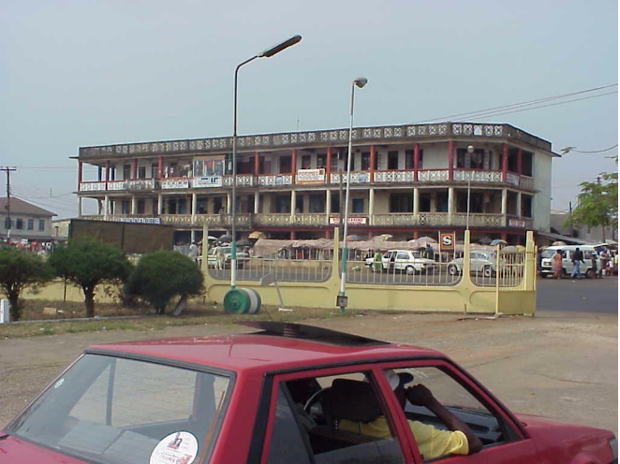

My latest plan was to visit Mexico’s sick mother in her village, just the other side of Benin City, a 4 hour drive to the west of Port Harcourt. After expressing my interest, Mexico was instantly sold on the idea, and plans where put in motion. Anita agreed that it would be good for me to get away and see some of the real Nigeria. “Things are different outside Bonny Island, here is not the true Nigeria” say all my operators. They also told me that travel is quite safe and no problem outside here. Once the plans where in place, Anita was talking to her friends who all thought:
- I was crazy for wanting to go, and
- Anita was crazy for letting me go on such a dangerous mission.
She re-thought her decision and withdrew permission, but it was too late I was going!

I attempted to make a booking on the boat to carry us to Port Harcourt, but Mexico only being domestic staff was not allowed to travel on our boat, and had to go on the community boat, a small fiberglass boat with 2 outboard engines. I would have to go on our boat and wait for Mexico to arrive. No way, I told them I would travel on the community boat too, with all the local domestic staff! Talk about getting in with the locals! The boat was noisy, a bit rougher and only had planks to sit on. But the journey was just as fast as our boat and not too bad.

We traveled to the Edo line bus depot in PH where we arrived at 10.30am to be told “It is not possible today, the buses have gone. You should be here early.” So we hired a private charter car to take us to Benin, and off we went on our adventure into the unknown. My confidence in our vehicle suffered a set back when only 10kms out of Port Harcourt we stopped at a small village surrounded by broken cars and a dozen men fixing them, with smoke coming from our front left wheel. It seems new brakes had just been fitted and where a bit tight, so some minor adjustment and we were again on our way.

The next excitement came as we traveled through Bayelsa state, next to Rivers State where we live and a well known hot spot for trouble, we were stopped on the road by road tax revenue collectors. It appears that some of the locals don’t think the government gives them enough money, so they have resorted to collecting it themselves. After stopping the car with a plank of wood with nails ready to “spoil the tyre” as they say, the boss man asked our driver for his documents, which he produced including a valid road tax certificate for Bayelsa state. “This certificate is for state tax, we are collecting local tax” he said angrily. He then looked in the back seat and seeing me, Oyibo (white man) claimed that this was a company car and would cost N14,000 to pass. (Remember the average laborer gets N300 per day here…) Mexico told me to stay in the car or it would make things worse, while a raging argument went on outside. When we refused to pay 2 of the men started deflating the front tyres of the car, at which point I leapt out and demanded they stop and took over negotiations with the boss man. (Scary stuff or what?) After secretly dashing some of men N100 five times, the boss man agreed to accept N1,000 and let us pass. 2 kilometres up the road, the bitumen was in very bad condition, resulting in us having to drive very slowly. I said to Mexico, with all the money they collect you would expect a better road, to which Mexico replied “Masser they will eat this money themselves…” Photo 1: The tax collectors I secretly snapped out the back window!
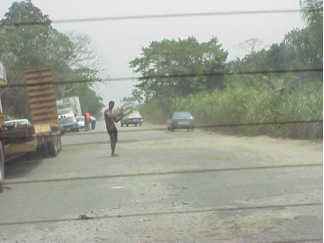
After a long 4 hour drive, with white knuckles from gripping the back of the drivers seat as we hurtled at up to 130kms down the road, through villages with people about to dart in front of us on their motor bikes, any normal driver would slow down, or in Oz the speed would be restricted to 60kms, but not here! You just use your horn all the way through town and your out the other side in no time flat!
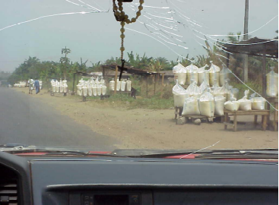
We passed small villages with mud huts, all very interesting, and a couple of village with many bags of eba stacked in road side stalls for sale. Eba is used to make Garri, which looks like playdough and tastes a bit like mashed spuds. Eaten with the hands, and dipped in thick soups, it is a popular dish with the locals.

On to Benin, (pronounced Bini by the people who live there….) then out the other side for a further 1 ¼ hours to Mexico’s village. They where all happy to see us, and Mexico’s mum, although very frail was pleased to see us and thanked me constantly for looking after her son. She had recently been in hospital after a fall. His sister changed into her best dress, then they all sat in Mum’s room for a photo.
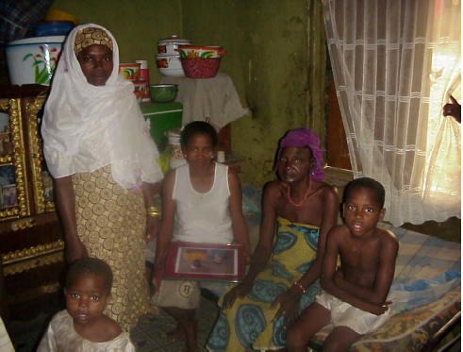

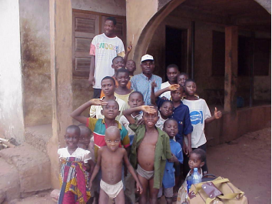
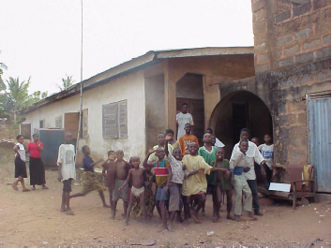
Mexico’s brother arrived in his taxi and took us back to the place where we could get a car back to Bini. It was an old Peugot 504 with no carpets, no door linings, windows that did not wind up, and the whole car shuddered and shook all the way, with not a straight panel anywhere! At the change over point we found a small Toyota carolla to carry us back, but even with just the 2 of us, we had to buy all the seats and it carries 6 passengers. (In a carolla??? I don’t think so…) 4 in the back seat, and 2 in the bucket seat in the front. I felt I was being taken for a ride without even leaving, and refused to pay. Mexico on the other hand begged that it was getting dark and we should just pay and go, after all it was only N900 and we beat him back to N700 (about $10). I later found out that he was not cheating me, it really was a 6 passenger car! By the time we got back to Bini it was 7pm and dark. I was glad to arrive as the headlights on the car where not too good, and the trip made me nervous. Mexico had been right to make a run for it.

The hotel I had picked out from the “Let’s Go West Africa” book had closed down, so the driver took us to a rather posh hotel, which was more then I budgeted for, but I was just happy to arrive so we stayed. Mexico stayed in the hostel just down the street. Mexico being proud of the hotel he selected asked me “You like hotel Massah?” to which I replied “No Mexico, too many Oyibo’s!” Once we got to the room, he insisted we ring Mum to tell her we were OK, but of course the phone line to Bonny was down, and remained so all night. (He was worried about Anita the whole time he had me away, knowing Anita did not really approve of me going.) I only managed to get a message to Prescillia after Anita had gone to work the next morning. The power also went off several times in the evening before I gave up on the TV, and sat in the pitch dark relaxing in the bath before going to bed early.

The next day, we went shopping to buy something for Mum and the boys. We saw some wood carving with potential, then we toured a whole street of bronze foundries. Bronze was first created for the old Oba of Benin (the king) as he had a thing for bronze. Now copies of the artifacts in the palace are turned out by the dozen and sold all over Nigeria. I already have a couple of very nice pieces and did not see one any better, so passed on the bronze. The only thing I liked was a statue of an elephant as big as a car! The price was very affordable and I had visions of it in the front garden in the residential area, and then the garden in Aberdeen St. But Anita didn’t think it was a good idea!
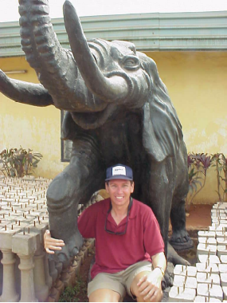

Off then to the museum which had lots of artifacts from the Oba’s palace including the exercusioner’s sword, which had killed more people than the Kobe earthquake! Mexico was telling about the power of the Oba. He was the one who got the British to leave Nigeria in 1960 returning independence to Nigeria. The customs surrounding the Oba are based on human sacrifice and when the Oba died they killed 7 people to put in the ground before they can put the Oba’s body on top. Apparently when this Oba dies, the same thing will happen, even if it is the 21st century.
In the afternoon we went for a drive along the river to Sapele, another township out of Bini before retiring to the hotel pool side for some “star” beer. We went to the restaurant for a lovely candlelight dinner courtesy of NEPA (Nigerian electrical power authority, or ‘never expect power always’ as it is better known) who were having a holiday that day. Another early night ready for the morning journey back to Port Harcourt.

One of the craft
shops in Benin>
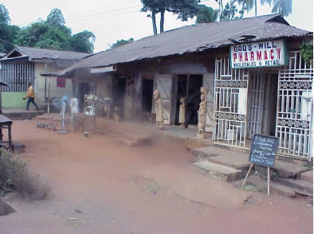
We arrived at the Edo line terminal early and book ourselves onto a motor. We then took a seat and waited for more passengers to turn up to fill the car, (a Peugot 504 station wagon with 400,000kms on the clock). The car carries 7 passengers which would be very squashy, but as the time went on, they let us go with only 5 passengers.

Now remembering that this car and driver has been waiting maybe 1 hour before being ready for departure, we all got inside and closed our eyes for prayer. One of the lady passengers in the back said a beautiful prayer to make our journey safe. I’m not talking about a simple one like you would say before eating, I’m talking a 10 minute sermon here! We blessed the car, the road, the driver, then asked God to soak the tyres, engine and steering wheel in the blood of Jesus. Then we asked God to teach this fine driver to drive the car safely on our journey. We then drove over to the bowser to fuel the car for the journey. All the praying served us well, as we made a very safe journey, and I thanked the lady when we arrived telling her the prayers had worked fine.

The trip home was quite uneventful, we were waved through police checks and even the tax collectors in Bayelsa state did not stop us being a government vehicle. The driver even had the cheek to yell abuse at them as we passed, so Mexico and I joined in by sticking our fingers up at them!!! (Aren’t I brave!) After arriving at the Edo line depot in Port Harcourt, the driver cottoned on to the fact that we had to get to the LNG jetty quick smart and negotiated a deal with Mexico to carry us for N300. Mexico thought this was much too expensive, and asked my opinion. I thought if we got there in time it was worth it. So off went out into the Port Harcourt traffic. The only problem was that the driver came from Bini and did not know PH, and I had always had a driver to take me and could not remember how to get there. So we asked a policeman. (Mum always told me if in trouble… ask a policeman!) He sent us in what I thought was the wrong direction and after some time we gave up. With time now getting desperate to meet the 4pm boat, I was without suggestion and was looking at the possibility of sleeping in PH for the night, but the quick thinking driver called over a motor bike taxi and asked him the way. Sure he knew exactly where we had to go, so off we went trying to keep up with him in the traffic, and losing him only once to find him racing up from behind telling us we had gone the wrong way.

All looked good traveling through unfamiliar streets with no time to spare, only to arrive at the local boat jetty to Bonny! (For the local villages, not oyibo LNG staff!!!) Mexico was yelling abuse at 500 mph, and off we went again. This time the area began to look familiar, and just as the motor bike was conking out and getting behind us, I knew where we were! So we lost the bike, and ended up at the jetty gates only to find the ferry left at 4.30, with plenty of time left!
(The motor bike eventually arrived at the gate and was yelling through the bars for payment, which I saw to.)
So, arriving home at Bonny, Anita and the boys greeted me dressed in Nigerian clothes, wearing Nigerian shoes and having been away from anybody white for so long was speaking pigeon to them.
“Ow yu de now?” (How are you today) “Whetty happen now” (What’s going on here?) I then settled in my lounge chair, with a “star” beer and parrot on shoulder. I think the parrot missed me the most and was glad to have me back…. until the next adventure!


