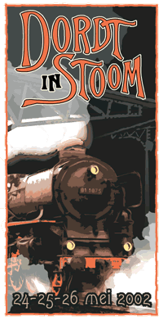
Friday 24th May 2002
So, I was off to the famous "Dordt in Stoom" festival for steam tugs! I couldn't believe that Anita had let me go, and the timing between me starting 28 days off work on the Wednesday and the festival starting Friday night couldn't have been better. Unable to get accommodation nearby with the expected 200,000 visitors coming in, I had to stay 1 hour away with the wife of a colleague who was on duty back in Nigeria while I was the man of his house in The Netherlands. Getting to Dordrecht meant taking 1 train to Rotterdam, then another to Dordrecht. During the train journey, I interrupted by a man of Eastern European decent walking through the carriages collecting small change, while his mate followed behind playing an accordian.
Finally I reached the station of Dordrecht and as I stepped from the train, I thought to myself, "so, this place does exist!" It looked like any other small village in The Netherlands and with absolutely no sign of anything to do with the coming events, I was beginning to wonder if I had come on the right weekend. But as I walked down cobbled streets towards the "centum" I saw a big poster on the grassy area in the middle of the road, just outside the Chinese restaurant, which made me feel relieved. So on walking down from the modern buildings towards the old town where the buildings all looked much older I was starting to feel lost. I checked my GPS, which indicated the docks area more to the left of the direction I was going. Eventually I found a large canal with pleasure boats all tied up along the dockside which led down to the River Lek and I turned to follow it.
Looking up I could see at the end of the canal, a "big" steamer funnel and I followed it down to find the famous British steamer SS Shieldhall. Coming out onto the dockside I could see a row of big steamships here for the weekend, but not many people around. Being late Friday afternoon, maybe I was too early as the real show didn't actually start until tomorrow. I found a sign saying "Dordt in Stoom central post" but unlike the Dutch it looked disorganised with the entrance looking like the back door of the pub kitchen. I looked inside and a lady making something inside told me to come in and go upstairs. So I wound my way up a rickety, narrow wooden stairway inside the pub to the top floor. Here was an office adorned with posters for the weekend, some nice pictures from years past, and maps on the wall for organising people, but nobody around except a lady sitting drinking tea. There were more people coming up the stairs behind me, but nobody to greet them. Eventually a man came in from another door talking on his 2-way radio and looking super busy, so I just asked him if I could take a program which he gladly gave me and I went on my way.
By now it was 6.30pm and I set off walking down the canal, which joins the river at the central post, there are beer tents set up and some caravans selling fast food but not many people. It's was cold and windy and drizzly rain started as I walked feeling a bit cold; maybe the weather was keeping the crowds away?
Looking down into the canal is the typical scene I recognize from all the magazine articles and internet photos I had been studying with a collection of little steamtugs lined up along the docksides, truly beautiful! The old buildings along the canal with the tall forest of steamer funnels rising from the boats, made me feel I had died and gone to heaven! (OK… not everybody's idea of heaven!)
Feeling really cold by now, I walked back up to the river, grabbed a hamburger from one of the caravans and decided that to stand here and watch the steam past by all the boats would be nice, but the commentary will be in Dutch and a much warmer option would be to pay the 5 Euro to board the large German icebreaker "Wal", joining them for the Vloofchoiw. (With my Australian tongue I called her name "Wol", but of course hearing the Germans, her name was actually pronounced "Vull") I was warmly welcomed aboard by a little old German lady who sold me a ticket and I made my way a quickly as possible to the open doorway from the deck leading into the boiler room. I was wondering if they would allow me to have a look inside when the fireman below saw me and ushered me to enter. I didn't need a second invitation, and was in like a rat up a drainpipe.
I was now standing on a grating walkway running across the top of the boiler room to a similar door on the other side. Looking down I could see 2 D-type water tube boilers sitting back-to-back. The fireman was indicating I should come down and have a closer look. He told me I could look and do anything I wanted. "Almost anything" I corrected him and he thought about this then agreed, "OK, almost anything!". Each boiler had a large single oil burner and I stood there following pipework with my eyes trying to figure it all out. The makers plate here stated they had been built in 1964, and I already knew the ship itself had been built in 1938, so I asked the fireman if she was originally fitted with water tube boilers? But he didn't understand English too well and couldn't tell me.
Everything was so clean and beautifully painted, she looked immaculate. The fireman pointed to a small door in the aft bulkhead which I put my head through, and looking up was surprised to see a huge triple expansion engine already turning dead slow ahead to warm through ready to go to sea. Looking at the huge crank she must have had a piston stroke of about 48"! Everything again was immaculate and as I looked towards the aft flat behind the thrust bearing, the 8" main propeller shaft, was rolling slowly with the oily doormat tied over the top polishing as it turned. With the gleaming brass, engineroom floor plates you could eat your dinner off and all painted a pale/creamy green and white it was truly a thing of beauty!
There was a tall German man standing with his hand on the throttle valve, with slick back hair and big sideburns looking like and old rocker from the 50's. I asked him if he was the chief to which he replied, "Yes". (He didn't look like a chief) So I told him this was the cleanest, best presented engineroom I had ever been in. The engine room was full of tourists all standing looking agog, hypnotised by the sight of the big crossheads moving up and down. The telegraph clanged, signally the captain was ready to head out and an older German man appeared from somewhere, kicking "Elvis" off the regulator valve and taking control himself. Ah, the real chief engineer!
We left port and cruised at dead slow ahead. I went out on deck to see we were being followed by the SS Shieldhall with a small diesel tug assisting her from the bow. Many smaller boats then followed our lead as we headed down the river. About 1 km down river, we attempted to turn around, but being such a big ship she had a lot of difficulty coming around. One of the coast guard launches came along side our bow and pushed us around like a little tug. Now I see why the Shieldhall has a tug on her bow! Back down the river we go, then back up again.
During the trip I entered the saloon area of the ship, which had a little German bar with "Becks" beer on tap and so thought I should try one. I was talking to an old German man who was both fireman and chief ship's electrician, and his wife was the lady behind the bar. I was so happy, I decided to buy one of the windcheaters (sweatshirt) they had for sale with the line drawing of the ship on the front. The little old German lady threw in a couple of postcards and the badge from the ship as an extra.
I ventured back down below to watch the engines maneuvering for the turn around again. Then stood and watched the steering engine doing her bit. All very interesting. But the maneuvers where becoming rather strange to what I was expecting. So I went back up on deck to see where we were. Coming on deck I noticed that even with engines turning we were not moving. Something funny was going on. The wind was quiet strong blowing beam on to the ship and we had been pushed very close to the river bank. The chief engineer came out on deck and told me what I had already suspected; we had gone aground! The small coast guard boat came back and pushed frantically. Then there were 3 small boats pushing. As the time passed I lined up some lights ashore with something on the ship and found us to be stuck fast. One of the smaller steam tugs, the "Adelaar" came over and passed a rope up to the bow of the ship which the crew made fast. They took off with the man on the tug still holding his end of the rope. He tried to make fast with a couple of quick turns on the bits but they were moving off too quickly and the rope just slid off. With no other option, he walked his end of the rope down the deck to the stern where we dropped it in the sea. Everybody on the "Wal" started laughing!
Then the cavalry arrived! 2 big diesel tugs from the port of Rotterdam, who happened to be there came over and took over. So with 3 little boats pushing and 2 big tugs pulling we were again on our way, straight back to our berth 1 hour late! I was in a bit of a panic, as the information I had gotten from the internet said the train service from Rotterdam Central station to where I was staying was finishing at 11.30pm and it was already 11.15pm! There was no way I was going to make it, and the lady I was staying with will be worrying and possible not happy with me. I ran from the docks area all the way back to the station, boarded a train for Rotterdam without having to wait too long, then luckily, the trains were still running and I arrived home at 12.30am, sneaking off to bed without waking the household.
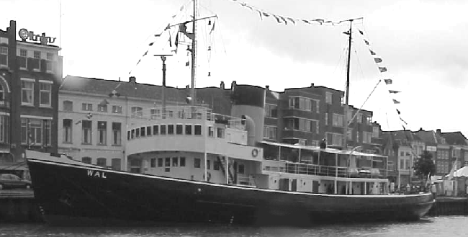
Saturday 25th May 2002
I woke up at 6am with the sun coming in through the thin blinds, tossed and turned a bit and finally went back to sleep, and didn't wake up before 9am! I headed out, back on the train arriving in Dordrecht at 11am.
Out the front of the station was a caravan selling tickets for the event. I decided to buy a full day pass for 12.50euro, which covered everything, the rides on the steam train, entry to the model boat show, vintage bus transport and unlimited entry to the steamships. The cue for the buses was far too long and after attempting to board 2 buses which were both swarmed with people I went back into the station to see the steam train which had just arrived. It was doing runs a few kilometers down the main line to where the model boat show was being held. I watched the train depart and seeing the bus cue was no smaller decided to make the 15-minute walk down to the docks area as I had done the night before.
On the way down, I decided it was hot chocolate time! (A habit taught to me by Anita!) So I stopped at a small café near the docks and ordered a pancake with cheese and bacon for brunch. When it came it was bigger than the plate and far too much to eat! But I managed. Just as I left the café the rain came down. Everyone was ducking for cover so there was no room left for me, so I got a bit wet. Luckily it didn't last very long but now I was both cold and wet, and I walked around the ships in the dock while drying off.
The docks area was decked out with boxes and articles that looked like were about to be loaded aboard a ship. There were false fronts on some of the buildings with vintage cars parked outside, mock shops and pubs and people everywhere dressed in old costume, all really effective, adding to the atmosphere. There was also a great collection of fire fighting equipment with their vertical boilers simmering away ready for action, and 5" gauge railway line running up the street for the model steam train rides. On the opposite side of the docks small packaged boiler with a gas burner was set up with a couple of interesting engines close by. One was a horizontal mill engine, the other was a twin cylinder banjo pump built by "E.Green" and son of Wakefield, the same one famous for building boiler economisers. There was also a huge ships whistle with about 3 big pipes.
Another exhibit worth mentioning was a steam bucket dredger; not too big but interesting all the same. As it was running and people were going aboard to have a closer look, I followed too, finding a single furnace, oil fired, scotch boiler and a medium sized, horizontal mill engine driving the buckets around.
Heading out of the canal and back to the main docks area on the river, I went to see the famous SS Shieldhall. She is from Southampton in the Southern UK, and when we were there 2 years ago I we made a special detour to go down and see her, only to be told by security at the gate that nobody was allowed to enter the docks and there was no way of contacting the people on board, so we didn't get to see her. This time she was here and in steam after steaming 2 days across the channel to be there.
On seeing her, I was quite disappointed as the paintwork looked old and messy with rust stains streaking down her side. Part of the sponson too was broken off and the English crew all looked scruffy. I thought at least they would do some painting before they came. She was built by Lobnitz of Renfrew near Glasgow, Scotland; the same manufacturer as the steam tug we are restoring at home, "Lyttleton II". I went aboard and headed straight into the engine room, finding the layout too was almost the same.
She has 2 triple expansion engines of 800ihp each, and they were rolling over slowly with a big crowd of people standing looking at them. The engine room looked fine and a much better standard than the outside of the ship. The boiler room contained 2 triple furnace, scotch boilers, oil fired.
Coming back up on deck I saw the many steam boats moving around the river area, and upon closer inspection, I noticed the beautiful steamer from the Rotterdam museum, the "Pieter Boele" about to come into the passenger berth starboard side to. Then at the same time I noticed the old steam tug "Scheelenkuhlen" also attempting to come along side the same berth from the other direction and port side too. Who had right of way? I was just thinking how confident these tug captains are, steaming so close each other with no fear of collision, and how if I was the captain of that tug, I would be in panic mode and calling for full astern by now to avoid colliding with the "Pieter Boele". Just as I thought that, I heard the engine room telegraph on the tug clang, and a huge wash from the stern appeared in the water. But just like the titanic approaching icebergs the 2 vessels continued to move closer together despite the decaying speed until 'crunch' they kissed each other on the port quarter of the bow. The "Pieter Boele" has a large bowsprit hanging out and I was convinced it would be broken off, but they just moved over each other with a scraping noise until the tug finally began to move astern, and with the bow pushed to starboard the stern now was heading for the wharf, but luckily the captain regained control and moved off shaking his fist to the other captain who was yelling abuse back. Overall, no visible damage to either vessel! Now that I was standing on the very back of the "Shieldhall" I wondered what steering gear she may have. I looked into a small deckhouse nearby to see she was fitted with a famous Scottish invention, the "Brown's steam tiller", all painted up beautifully.
Back out onto the docks, and the crowds where thick, making walking slow. The crowd waiting to go for a boat ride too was huge, so I decided to go and see my friends on the "Wal" again. My feet were tired and I was a little cold and decided to go and sit in the saloon lounge and try one of their draught beers. I was the only one sitting there, with the little old German lady smiling to me, I was feeling very relaxed so decided to have a second one. When it was finished, I thought long and hard about another and looked out through the port hole at the cold gray sky and decided to have yet another final beer. As I paid over the money for number 3, the heavens opened up outside and the rain belted down. As I sat down again I thought what a great decision it had been. Now sitting there in the best seat in the saloon, I was surrounded by lots of people all looking for shelter, and when they saw me relaxing with a nice ale, thought what a good idea, but the next beer the lady tried to pull signaled the end of the beer! So I had really made a great choice!
Well it was now mid afternoon, and I had an all day ticket to see everything and had not made the most of it. So when the rain stopped I headed back up to the street and caught one of the buses back to the railway station. Again the crowds were huge and I couldn't get onto the vintage bus, but instead settled for a modern bus that was being used to help ease the cue.
Once back at the station, I watched the steam train arrive and stood taking photos with all the other rubbernecks before climbing aboard. Once inside you never know what kind of engine was out there which made me wonder why steam trains were so popular and nobody liked steamships. As the train went along, 2 men walked down through the carriage selling postcards. Thinking of the music men on the suburban train, I turned to the man sitting next to me and said "Shouldn't the second man be playing the accordion?" but he just looked at me like I had just spoken Chinese to him (heh, maybe it was double Dutch?) and turned away, not getting my joke. The train journey lasted only 15 minutes down to the other side of town to a huge factory. Inside the main gate there was a large warehouse, which was being used to host the model boat show. I showed my ticket and went in. There seemed to be more second hand train set stuff than model boats. There were also model cranes, with some of them standing 3 metres off the floor. A big collection of model trucks too where there, with some men driving there models around a model city painted on a large board on the floor. They also had a boat pool with some of the model boats doing circles like the "Queen Mary" locked in a bathtub. There was also a lot of model engineering equipment for sale and plenty of model steam engines and locomotives on display. They even had dolls houses, and model amusement rides; Overall a great collection.
I walked back to the railway line to watch the train coming back to collect us. They have an engine both front and back to avoid having to turn around, as they are just using the single line back and forward to the station. It was 6pm by the time I reached the station and was wondering if I should just go home, but thought maybe one of the ships is taking a cruise out for the evening. I walked back to the docks to find not much happening, so walked back up through the town to the Chinese restaurant for dinner. I was happy to be on my own with nobody telling not to eat the Chinese food, but when it came it was just so-so, and I wished Anita had been there to tell me not to do it!
Back on the train, I thought about stopping in Rotterdam and having a look around, but was so tired I just went straight home to bed.
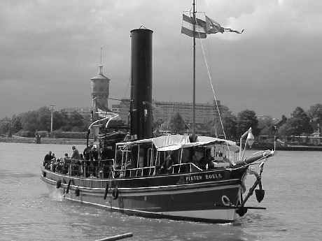
Sunday 26th May.
Again I took the journey by metro from Spijhenisse to Rotterdam Central. I needed change for the ticket machine go give me a ticket down to Dordrecht and so walked around finding the sandwich bar was open. I brought a ham and cheese roll with orange juice, then got my ticket. There were a lot of strange looking people hanging around the station, but felt safe walking behind two burley policemen. As we passed this dirty looking, old black man rolling himself a huge cigarette, he looked up at the policemen and said "What you lookin' at?" and the police just turned their heads and kept walking like they had infringed his personal rights! Seeing first hand how ineffective the police were, I suddenly didn't feel as safe!
Getting off the train in Dordrecht early meant there weren't so many people around. The steam train too hadn't began to run yet either so I walked out the front of the station, and decided not to bother getting another day pass, but would do the 10 minute walk down the docks area myself, and set off along the quiet streets to the sound of distant church bells. I passed one of the squares in the city centre where a market was being set up. I had a quick look but most of the stall holders hadn't arrived yet, so I continued on my way.
At the docks most of the boats where still getting ready to make there way out for the day, so I did the usual lap, over the lifting bridge and around to the end of the canal and back again taking it all in before the crowds arrived. Some of the boats by this time had moved out and were starting cruises. I went to the ticket booth and having already decided to save the money on the pass that covers everything, just went to buy a couple of passes for the boat rides at 3.50 each. While waiting in the cue, I came to the decision that maybe I would need more than 2, so decided to buy 4. Then after paying the money over, realized I had paid 14 euro, when a pass for everything for the whole day was 12.50! So much for saving money!!! (You idiot!)
There was no cue to get on board a boat ride, so I fronted up and the first boat that was lucky enough to have me aboard turned out to be a visiting ship from the museum in Rotterdam, the "Pieter Boele". She looks a magnificent little steam cutter with a lovely bowsprit, all painted up immaculately. I boarded her and made my way with all the other rubbernecks into the engine room. She has a small triple expansion engine and single furnace oil fired boiler. The engine is almost closed in at the front with extended panels coming up to almost obscure the view of the cross heads from the front. The side too was covered in cage and I thought about how dangerous it must be for the engineer to feel the bearings, probably endangering himself all in the name of stopping the public from touching the engine too.
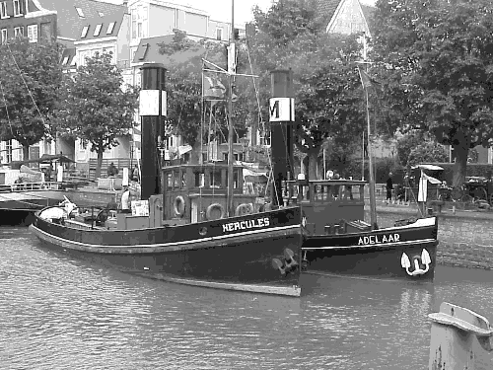
Without too much cue I waited again and this time boarded a little steam tug "Vol Harding 1". She looked like a working ship and not really presented like a museum piece, just as she would have been in her working days. She had a nice little triple expansion engine, and I was surprised to see she was fitted with "Hackworth" valve gear, which made an even more interesting display with the extra slippers for the valve rods pushing sideway from the crank. The engine valves too were spaced between the cylinders instead of all being in line, making a compact cylinder block and less engine room space. Without any warning, the engine sprung to life which surprised me, as she was controlled from the bridge and not the engine room. I told the engineer it was his biggest mistake to let a mere sailor control his engine! The engine now running at a great rate of revs was making more clangs and bangs than a chaff cutter, including some serious metallic knocks in the IP crosshead and big end. The engineer who didn't look much older than Mitchell could see the look on my face and told me not too worry, after this event they were going to lay her up, cut the deck open, remove the engine and do a total refit of the whole vessel, then put the engine back in. They had just been granted the funds for this ambitious program. She also had a single furnace scotch boiler, coal fired and I was amazed to see a collar type thrust bearing with all the cooling water pipes weaving in and out like spaghetti.
I was back in the enormous cue waiting for the next boat and determined to get aboard the "Christiaan Brunnings", but she arrived too soon and left with me still in the cue. The next boat coming was "Pieter Boele" again, so I stood aside and let everybody pass me, and waited there until I was finally first in the cue when the "Christiaan Brunnings" finally came back after her cruise.
She has a neat little compound engine and twin furnace, coal fired, scotch boiler. I told the crew the story of how I had visited her in Amsterdam 2 years ago, at the Maritime museum and was unable to get a close look at her, but now here I was with her hot, happy and alive right before my eyes! After asking some technical questions, the crew realised I was not just another tourist and was keen to hear of my experiences in Australia.
The next ship I boarded was a smart little tug "Nordzee". The thing that first took me with her, was the fact she had frilly curtains around the windows of the forward saloon with pot plants growing on the sills! Her engine room was warm, dark and compact with a coal fired, twin furnace scotch boiler and compound engine with Joy valve gear. As we were returning at the cruise end the fireman closed the funnel damper, which filled the engine room with smoke. To help ease this situation, he opened to a valve on a manifold on the starboard side of the boiler and a steam powered exhaust fan spring to life removing the smoke! Neat trick!
Back ashore, the crowds were beginning to ease and I was feeling pretty thirsty. There was a rock band playing outside the hotel, but closer to where the passengers where getting on and off the boats there was a man standing on a tarpaulin clad stage with a guitar singing. And he wasn't bad! There was a collection of drunks sitting around with various style of bad hair cut (all in the name of trendiness) singing along while drinking dark beer from a very large glass. So I went to the beer tent nearby and told the man I wanted one of those too. It turned out to be "Palm" from Belgium and with the atmosphere went down very well. A couple more and a bit of a singsong and I noticed the "Christiaan Brunnings" coming back to drop the passengers for the last trip of the day. So I rushed over to get a photo of her coming in. As the passengers disembarked I noticed the engineer on deck beckoning for me to come over. He asked if I would like to join them in going back to their berth, which I did. After shutting down and a couple more beers, cheese and bickies with the boys, they ask me what I had planned for tomorrow (Monday). I told them I would be back on the train to Amsterdam. "We have to take this ship back to Amsterdam tomorrow, a 9 hour trip. Why not join us?" But would I be able to get back to Dordrecht with my belongings by the agreed departure time of 9am? Shouldn't be too hard.
Monday 27th May
I rushed back on the train to Rotterdam central, got my ticket and boarded the train to Dordrecht 10 minutes ahead of schedule. I was sure to meet my deadline. But… (there is always a but in these stories…) in my haste to get the first train to leave the station, I picked the one that stops at all the stations. OK, no problem, it will just eat a bit into my extra 10 minutes. That was OK until the station just before Dordrecht the train came to a stop and didn't move for more that 10 minutes. I got out my GPS and could see I was only 3 kms from the docks area, while the train station is 1 km. So if I jump off this train now, it will just mean 2 extra kilometres. While contemplating this, the train finally moved off and I arrived at the station 10 minutes behind time. OK, all is not lost as I ran down the streets, bringing back memories of Friday night when I ran the other way, except this time I had my bag and suitcase in toe!
With still another 10 minutes to spare I finally boarded the "Christiaan Brunnings" (did I mention she was built in 1900, making her 102 years old?). The crew were happy to see me and helped me to stow my belonging and set me up with a hot cup of coffee before we finally departed. I could see up the river the SS Shieldhall also being assisted off her berth for the journey to England, but she was going the opposite direction to that we were going.
After we were underway and settled, I pulled out my GPS to find us doing 110rpm and making a steady 8 knots. At this speed she consumes 225 kgms of coal per hour. How do I know this? Because 30 minutes into the trip, the fireman handed me the shovel and said for me to try putting on a charge of coal. "No trouble, I've done this before." I told him, and he watched with interest how I laid out my fire. Then he disappeared and returned with a pair of overalls and gloves telling me "You are now the fireman for the next watch. We will work 2 hours on, 2 hours off".
So I was now the 2nd watch fireman. The coal quality was very good so I had no difficulty in keeping the steam up. At times I made a bit of black smoke which cleared with the addition of more secondary air (just like the text books say). The only difficulty was the bunkers were quite low on coal and it had to be constantly trimmed to keep enough coal at the ready. We twice had to go on deck and open the coal scuttles and with a long bar push the coal aft towards the stokehold door.
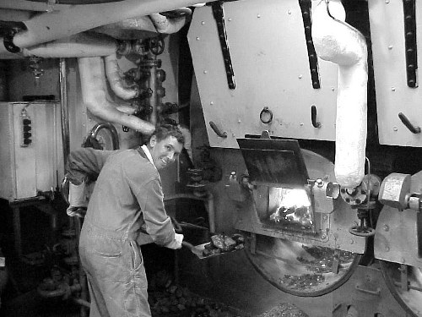
We steamed through many peaceful little villages and I was frustrated by wanting to be in the engineroom as well as see the scenery on deck. So often I would throw on a charge then go up top for a look at the scenery. While standing on deck, the cook cam walking past holding a large tray of parfaits that he had just whipped up. They had like a custard in the bottom and whipped cream and chocolate sprinkles on the top. Boy, we never get looked after like this on "Wattle"! Wait till I tell the boys at home about this! An hour or so later and I was called into the saloon for lunch, and found the cook had whipped up this big pot of macaroni with meat and vegetables, it was delicious, and I told them all I was not going to go home!
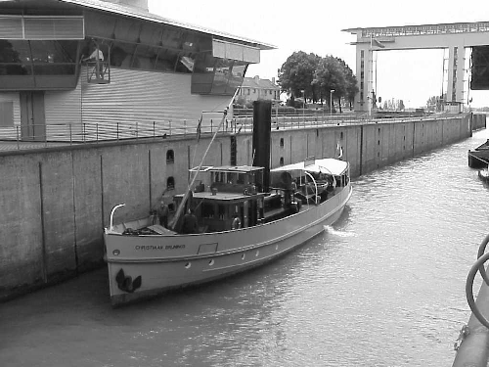
We steamed up the river 'Lek' to the city of Utrecht, then made a left turn into a large lock. Our speed had been timed to arrive at exactly 1pm when the lock opened to receive traffic heading North, and as we rounded the bend we could see the lock already open with the boats from the South already approaching; perfect timing. One of the boats coming out, was the "Peter Hien", the Dutch royal family's yacht which made me dash below quickly for my camera.
Without hardly slowing down we steamed right inside and made fast. I climbed up the ladder on the lock side to the top, then ran over the sluice gate to the other side to take a great photo of the lovely little ship sitting there simmering away. Back on board I expected the water level to rise as we were heading further in land, but to my surprise the water level went down 2 metres. "Don't forget Amsterdam is built on a swamp" I was reminded by the other fireman, as he went back below to remove the covers off the boiler furnaces allowing the air back into rejuvenate the fire.
The canal was very long a dead straight all the way back into Amsterdam. We passed many factories and people riding their bikes faster along the canal path than we were going as we steamed up the semi-built up areas of outer Amsterdam. I was surprised how many cargo boats were traveling up and down these waterways. There are a lot of containers and other general freight still being carried up and down the canals. Some were very large ships or tugs with a couple of barges loaded with containers.
Another ship that surprised me following us astern with just enough speed to slowly pass, was a cross between a canal boat and an ocean liner. Coming from Basil in Switzerland it was loaded with tourists all out of deck with their cameras especially to take a picture of me in my overalls and sweat rag around my neck. (such a handsome devil-what?) There were many more in Amsterdam when we arrived and apparently they ply the Rhine river between Holland, Germany and Switzerland. It would be a good cruise to do, but not as good as the one I was already doing. And the cook was back, this time with a big box of chocolate ice creams. These boys really do it hard!
The last bit of excitement was the arrival into Amsterdam. We had finished coaling the fire and were just letting the remainder burn through to carry us home. But our berth lay behind a very low railway bridge. Now here was the next surprise. The deck crew undid the forward funnel stay then cranked a small winch aft that pulled the funnel into a horizontal position, so it looked like a big cannon. The mast too was lowered down onto the top of the wheelhouse and under we went, and up went the funnel and mast for the remaining 100 metres.
We made fast inside the Amsterdam Maritime museum, which was already familiar to me having visited there twice before. After packing up we sat in the forward saloon for some distressing beer, while the Captain, Engineer and cook drank some Geneva (Dutch gin). The tourist boats from the centre of Amsterdam kept coming past, entering right inside the museum for a quick look at the collection of boats, having a good look at us sitting inside then turning back and going on their way.
One of the crew told the captain he should make a speech. So he started off in Dutch with a serious look on the crew's faces. I had no idea what he could be saying. Then without warning, he changed to English and said "And a toast to our special guest who is now an international fireman!" As they raised their glasses to me, I got that old 'warm fuzzy' feeling back in the pit of my stomach! Visit the web page at: http://www.dordtinstoom.nl

