BAY STEAMERS LIMITED

PROPOSAL FOR CONVERSION OF

The STEAM SALVAGE TUG

LYTTELTON II
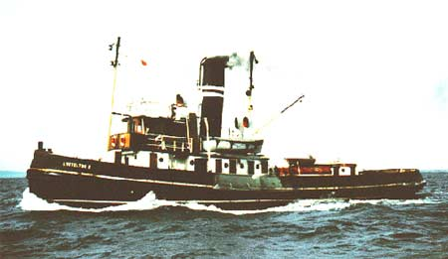

to become

The luxury STEAM YACHT

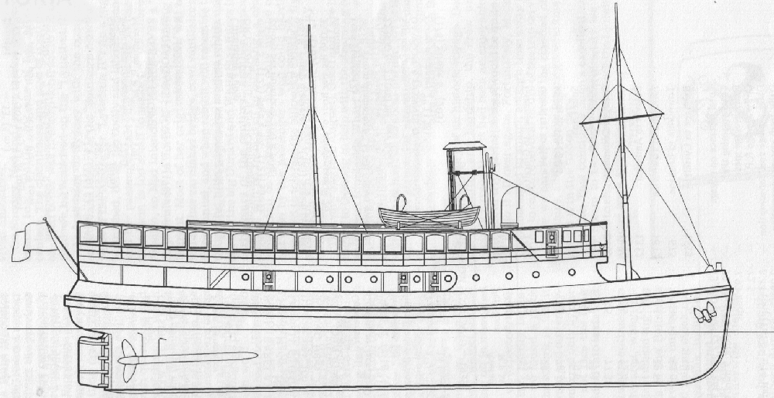
“insert-your-name-here”

Mark Dye

Chairman

Board of directors

BAY STEAMERS LIMITED

Contents:
Page

History 3

Where we are today 4

Plans for conversion 4

Proposals:

Accommodation 5

Engine room 5

Boiler room 6
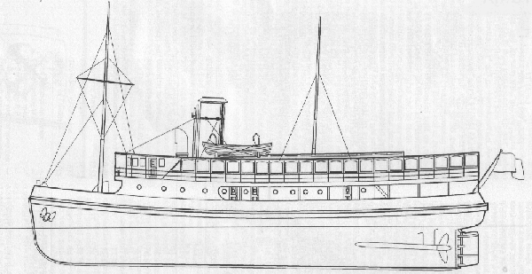
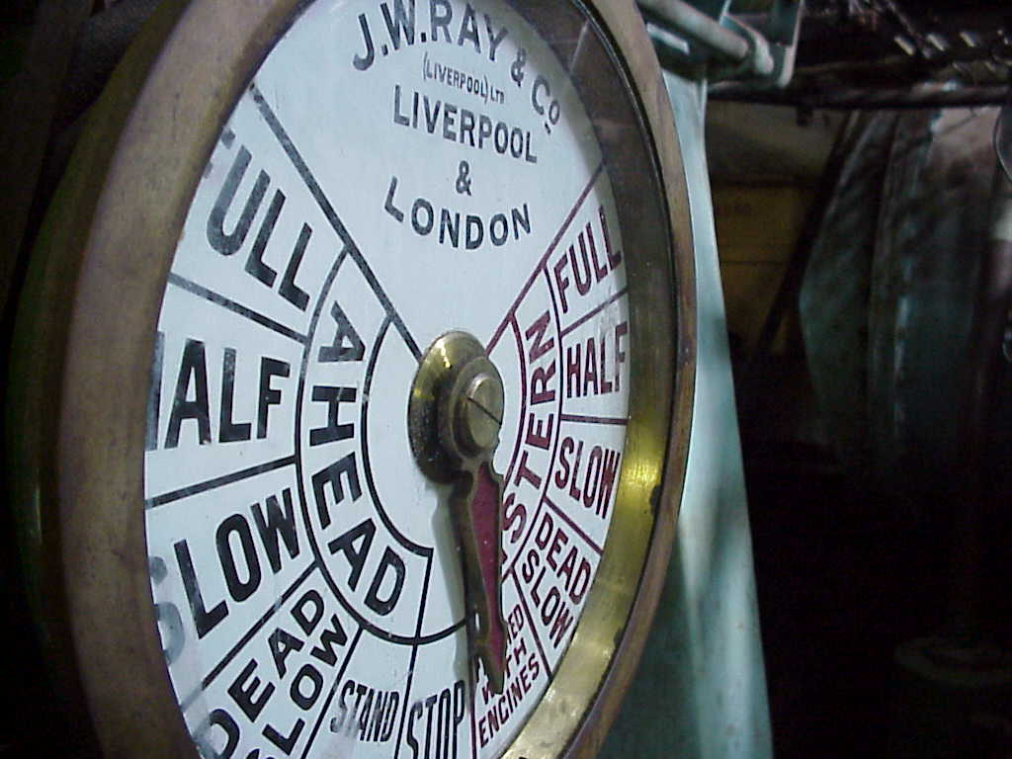
History
The twin screw steam salvage tug “Lyttelton II” was built in 1938 for the Lyttelton Harbour Board, New Zealand by Lobnitz & Co. Ltd., in Renfrew, just outside Glasgow on the river Clyde, in Scotland. She departed Scotland with port holes boarded up and bags of coal strewn around her decks, on a three-month voyage, which took her through the Suez Canal arriving at Lyttelton New Zealand on June 8, 1939.
With a length of 120’, a beam of 31’, and weighing in at 600tons, she has a bollard pull of 13 tons while drawing 13’ of water at her stern. She looked very smart with her teak wheelhouse, as she was pushed through the water at a speed up to 12 knots by her 2, 625 IHP triple expansion steam engines with independent condenser.
After a faithful career of 40 years as the principal salvage tug for the Pacific region adjacent to her South Island home port, and still in Lloyd’s 100A1 survey, she was laid up for a short while before being offered for disposal. She was eventually sold to a consortium of steamship enthusiasts associated with the Sydney Maritime museum, and steamed to Sydney where she operated as a tourist vessel for a short time doing leisurely trips around Sydney harbour using old Sydney telephone books soaked in diesel to supplement her coal fuel.
After another short lay up she was acquired by a gentleman from Melbourne who intended to convert her to a cruising restaurant ship, and in 1987 she again found herself on the high sea towards yet another new home in the Port of Melbourne.
When she was finally lifted out of the water on “Duke & Orr’s” floating dry dock, it was found her hull had deteriorated further than expected, forcing the cost of repair high enough for the project to be re-considered.
She was then acquired by a group of steamship enthusiasts in Melbourne who had successfully restored, maintained and operated the little steam tug “Wattle” for a number of years around the port of Melbourne. Labouring hard against the elements in an attempt to reduce further demise of the ship, she proved to be too big, for the limited financial backing available, and the project eventually ground to a halt and the vessel fell more into disrepair.
In September 2004, over a restaurant table in South Melbourne, a small group came together to discuss her future. All agreed that a vessel of this type; now so rare, could not be sent to the breaker’s yard like so many of her sisters, and efforts should be made to prevent the vessel being lost. This group made a successful challenge to the board of directors, taking control of the company “Bay Steamers Limited” and its sole asset, the steam tug Lyttelton II. An interested benefactor has agreed to provide funding towards a new assault on this stalled project, and work has re-commenced on the monumentous task of securing the ship from further deterioration, before turning the ship back into an icon for the Port of Melbourne in a new role of luxury steam yacht cruising the waters of Port Phillip Bay.
With a new found optimism spurred on by the financial support at hand, the new board of directors have given way to the little by little approach, and are thinking “big” with grand plans of totally re-building the ship from an old steam tug into a new bay cruiser, achieved by removing the existing superstructure and completely rebuilding her in a metamorphosis for her new life.
Where are we now?
The new board have hit the decks “legs running” with ideas and proposals coming thick and fast. With the absence in the port of Melbourne of a slipway large enough to accommodate our ship, a full ultrasonic thickness survey has commenced on the vessel from inside the hull without the need to remove her from the water. Discussions with Marine Safety Victoria have already commenced, and a budget has been established for hull repairs. The results of the ultrasonic survey will be used to estimate the cost of repairs required to achieve MSV survey, and although the board remains optimistic that the repair cost will be within our budget limit, if this proves otherwise, the board will reluctantly be faced with the only remaining option of forcing the ship to be broken up with the sale of salvaged equipment used to recover costs.
A marine architect has been consulted and plans for her future role have been drawn up. With a clear conscience that the hull will remain a strong foundation for us to build on, most of the ship’s superstructure will be removed and rebuilt in her metamorphosis towards becoming an opulent steam yacht. The ships boilers will then be removed for surveying and restoration ashore leaving the weight of the now bare ship less than 400 tons, enabling her to be slipped in Melbourne for hull repairs. From this point, it’s only a matter of re-assembling our ‘jig-saw’ and fabricating our new superstructure.
The vessel will be re-named to something more appropriate to her new home in Australia. (Proposal still being considered.)

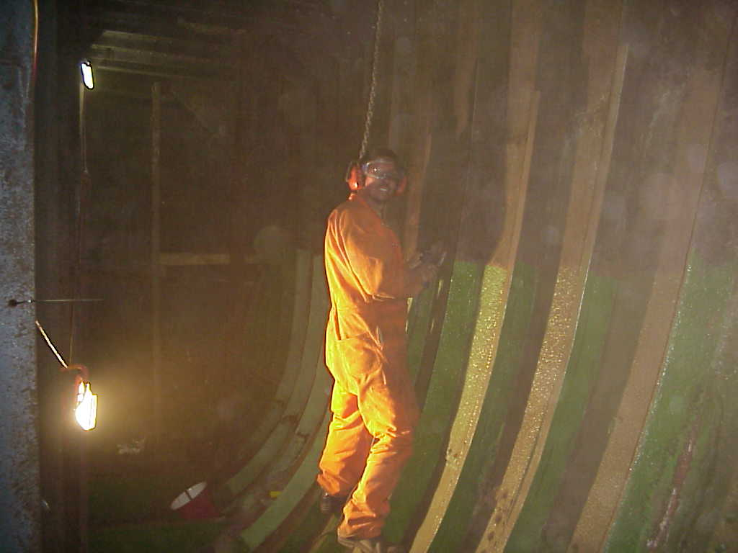
Plans for conversion
The ship will be?
Passenger limits?
Types of functions?
Places of operation?
Other stuff?
Proposal for ACCOMODATION
The ship will contain onboard, all facilities required for operation so that no shore based facility will be required other than 3 phase electrical power and domestic water.

Crew requirements
In line with this self-containment policy, the ship will have adequate accommodation for the needs of her crew in relation to mess facilities, sleeping accommodation and toilet/shower facilities.
This is to allow the ship to work in locations remote from her homeport while maintaining the necessary comforts required ensuring her crew are well rested. The current messing facility aft of the ships engine room is to be maintained for this purpose, with any additional requirements taken into consideration in the ships conversion.

Engineering requirements
Adequate storage facilities will be incorporated into the ship’s machinery spaces to allow the majority of maintenance activities to be carried out without the need for on shore facilities.

Boiler room requirements
All fuel storage, treating, cleaning, filtering and de-watering will be carried out onboard the ship with the connections for bunkering being the only interface with shore.

Proposal for Engine room
Where possible, the engine room will remain as originally built. Facilities will be incorporated for storage of all tools and spare parts to comply with the “self contained” policy.
The ship is currently fitted with 2, phosphor-bronze, heavily pitched “towing” propellers. It is proposed to swap them with the cast iron “cruising” propellers she was fitted with for the delivery voyage from Scotland, which we have in storage.
Proposal for Boiler room

Boilers
The current boiler room is fitted with 2 coal fired, 3 furnace, scotch type, fire tube boilers. It is proposed to remove these 2 boilers from the ship where they will be surveyed with the better one of the 2 being refurbished where necessary and returned to the ship in the aft boiler position with adequate space between the engine room bulkhead and the boiler front (now facing aft) to allow construction of a new firing platform. The boiler will be re-fitted with oil firing equipment using pressure atomisation and natural draught for the combustion air.

Steam loading
The ship will no longer need to be able to tow, salvage or fight fires and with a reduced cruising speed, the volume of steam required will be less than the present design. Also the ship’s electrical requirements will be supplied from diesel generation allowing greater flexibility required for wharf-side functions, which will also reduce steam consumption.
With the large surface area of water inside the boiler, as typical with the scotch boiler design, and the arrangement of dry pipes used to collect the steam from the inside top of the boiler, it is considered that the boiler can affectively evaporate more water while maintaining a good dry steam quality.
It is proposed the remaining boiler’s capacity will be increased through the following considerations:
- Oil firing will produce greater heat capacity from higher fuel calorific values, better more complete combustion while removing the need for firebox cleaning, clinker removal, grate slicing/cleaning and ash removal.
- Construction of a boiler feedwater economiser. With greater heat duty within the boiler, efficiency losses will be increased through higher boiler exhaust fluegas temperatures. This problem will be address with the construction of a convection heat exchanger to be located within the new smoke box located between the boiler fluegas outlet and the ship’s funnel, thus recovering these losses, while increasing boiler heating surface and reducing required heat flux with the boilers combustion chambers needed to maintain the higher steam loadings.

Boiler economiser
The new boiler economiser should have the following designs considerations:
- Minimal resistance to fluegas flow, as the boiler’s combustion air will be supplied through natural draught.
- Easy access to both fluegas and waterside for boiler inspection requirements.
- Formulation of design after close consultation with marine board surveyors to ensure all requirements are met and standards applied with current boiler codes of practise.
- The ability to withstand boiling dry, which may occur during boiler start-ups. A positive circulation system will be in place to circulate boiler water during start up. Carbon steel is able to withstand temperatures up to 400 degC without damage, which is well above the expected boiler fluegas range. Although not ideal, feedwater will enter from the bottom and leave through the top so any steam generated will be pushed out to the boiler ensuring the economiser remains flooded in the highest temperature zone where the fluegas leaves the boiler and enters the economiser.
- Considerations towards removal of soot build up.
- Sufficient pre-heating of boiler water to prevent dew point corrosion.

Boiler room
The new boiler room will have the coal bunker partitions between the boilers and the ships hull removed, and tanks for the storage of fuel oil will be fitted in this place. This space will also be fitted with fuel oil heating/pumping equipment. In line with the policy of having the ship as a complete stand alone facility all fuel storage, cleaning, treating, de-watering or filtering requirements will be met with equipment fitted into this space.
A new watertight bulkhead will be constructed at the forward end of the boiler room at the rear of the boiler.

Start up circulation
A boiler start up circulation pump shall be provided. For convenience, it will be electrically driven, taking suction from a line diverted from the boiler blowdown connection, discharging into the boiler economiser. This is to aid even heating of the boiler reducing start up times and eliminating thermal stress due to uneven heating of the boiler during start up. The eventual production of steam within the boiler will produce a natural circulation of boiler water and the pump can be shutdown.
The fuel oil heating and pumping skid should also be fitted with an electric pump and heater for start up purposes, or a separate diesel tank of start up fuel should be fitted.

Boiler forced draught fan
The existing boiler forced draught fan will remain in the current position in the ship’s engine room but generally will not be used. The boiler room will have the ability to be sealed and pressurised by this fan during occasions of higher steam demand required during long duration voyages such as bay crossings to Portarlington, Geelong or other destinations.
Ducting from the upper areas of the boiler room will also be fitted into the ship’s accommodation allowing hot air from the boiler room to be circulated by the forced draught fan to guest areas of the ship, providing some heating during the colder months of the year.

