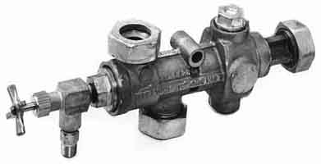
The Steam injector by Mark Dye
Is this the world’s most ingenious device?
How is it possible, that a pressurised fluid can be taken out and discharge back into the same vessel from whence it was taken? There can be no differential pressure, needed to support flow. Or can there? If ever there was a model to demonstrate why a steam engine is classified a “heat” engine and not a “pressure” engine, then here is the ultimate demonstration of that principle. So read on as we look past the magic, smoke & mirrors and “sleight of hand” revealing the hidden secrets of the steam injector.
The steam injector is indeed an ingenious device, being invented by the French physicist Henri Giffard and patented in the United Kingdom in 1858. It takes steam from a boiler, blasts it through some fancy cones so quickly, that it sucks up some water along the way, discharging this mixture back into the boiler it came from. Not only is it discharging back to the same pressure used to drive it, but with pipes, bends, nozzles, check valves and the like, all adding to pressure loss, the device overcomes all these and still manages to work, all thanks to the heat energy contained in the steam.
Perhaps Monsieur Giffard was sitting under Isaac Newton’s apple tree reading the best selling book of 1738, written by the famous Swiss mathematician Daniel Bernoulli, on fluid mechanics, explaining what I remember from my engineering studies, as “Bernoulli’s theorem”. It explains the relationship between pressure and velocity of a moving fluid (liquid or gas) showing that as the velocity increases, the pressure exerted by the fluid decreases.
An aeroplane wing, for example uses this theory. The wing splits the airflow over a longer path over the top, increasing the velocity of the air producing a low pressure on the wing’s upper surface pulling the wing up resulting in lift. Hey! Maybe I could use this principle to sail my yacht?
Then there are the laws governing the creation of energy, which dictate that the pressure energy belonging to the fluid, is converted to velocity or kinetic energy without being lost or destroyed. Simply put, the faster it goes, the less pressure it has, and when separated from the confines of our environment, the resultant fluid pressure can fall far below that of the atmosphere in which we are immersed.
So, you know the theory, let’s make it work! Turn on the steam. This will blast steam through the nozzle to create a pressure low enough, that atmospheric pressure will push water up the pipe into the mixing chamber. (Never say “the water gets sucked in!”) To make it work, we will vent the steam out an overflow pipe between the combining and delivery cones which enables flow to be established for starting the process. When the water enters, the steam condenses, further increasing the velocity to drive the mixture past the overflow and into the diverging delivery cone. At the point between the cones, the pressure is completely spent and the velocity so high that it pushes all the way through the second diverging nozzle where this non compressible liquid travelling at super high velocity is allowed to occupy more space, slowing down, and increasing in pressure until high enough to lift the boiler check valve and enter the boiler. That’s all there is to it… so simple eh? All we need do now, is adjust the water valve so enough enters without drawing air through the overflow into our boiler, and not too much water runs wastefully out the overflow. Water at the overflow also means we need more steam pressure rectified by opening the steam valve further, or increasing the boiler pressure. (The cones and nozzles are designed for a particular pressure and so a good steam pressure is necessary for them to work effectively.)
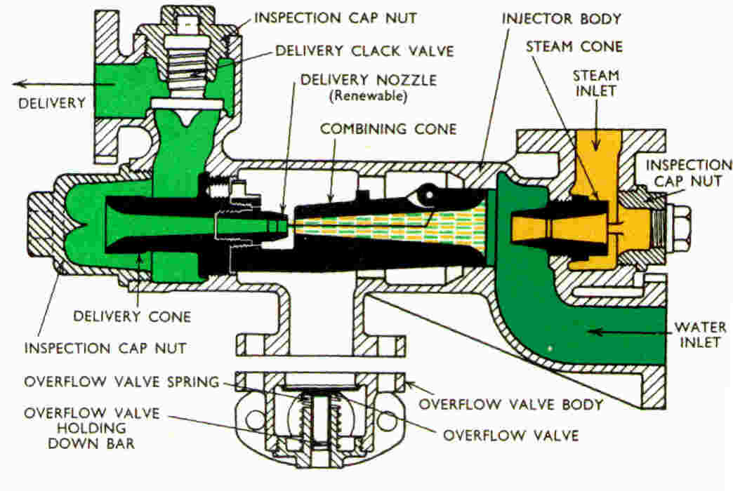
So how does the diverging nozzle convert the velocity back into pressure? Well imagine your little brother standing at the open window covered by a fly screen poking his tongue out at you while you are holding a rotten tomato. Placing it on the window sill hardly posses a threat, but chuck it as hard as you can, and even the resistance provided by the fly screen will soon be overcome for all but the seeds to splatter your cheeky brother after the velocity you gave it overcomes the pressure needed to strain through the screen. The splatter effect… As the velocity quickly falls, the pressure quickly rises!
So simple and reliable are steam injectors, that almost all railway locomotives use them instead of troublesome mechanical pumps. Even when the regulations say you need 2 methods of supplying water, they just give the driver and fireman one each! Many packaged boilers too have a feed pump, and the second method of feeding the boiler, is a cheap effective injector.
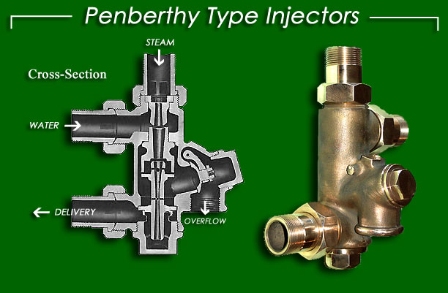
So if you are still thinking it’s the pressure that’s doing all the work, some railway injectors were even made to run supplied only with exhaust steam from the blast nozzle manifold. With a couple of extra cones and nozzles the low pressure, low temperature steam still has enough energy to feed water into the boiler. And of course the used up heat energy ends up in the water, so it’s efficient too! Yep… the good old steam injector just can’t be beaten even in the 21st Century!

