September 2000

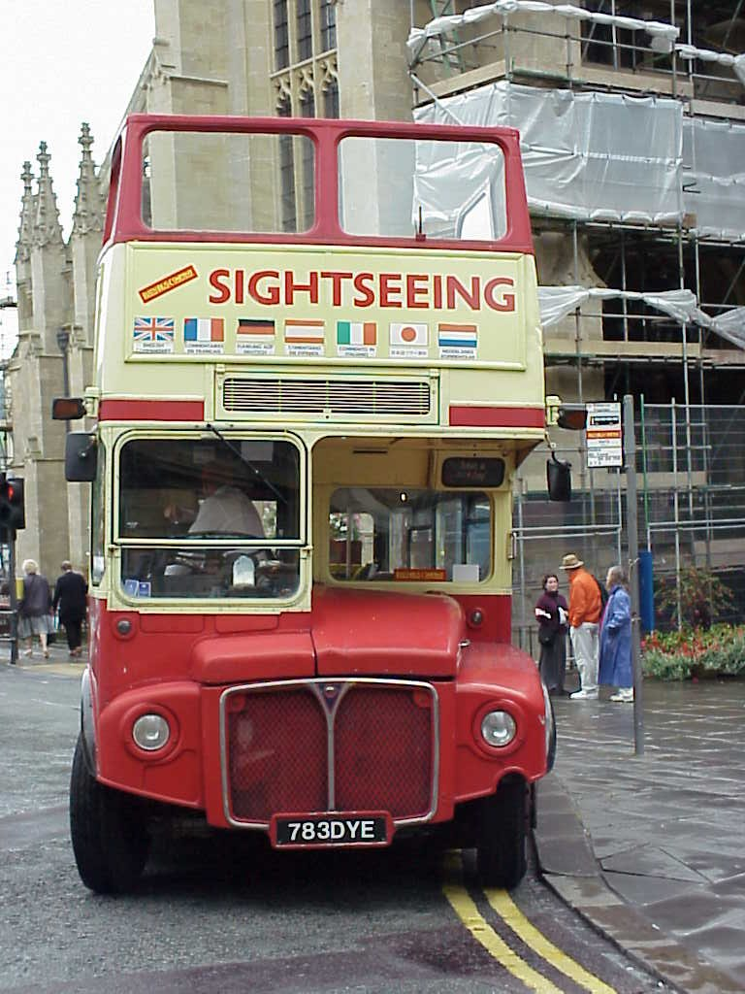

The Dye family
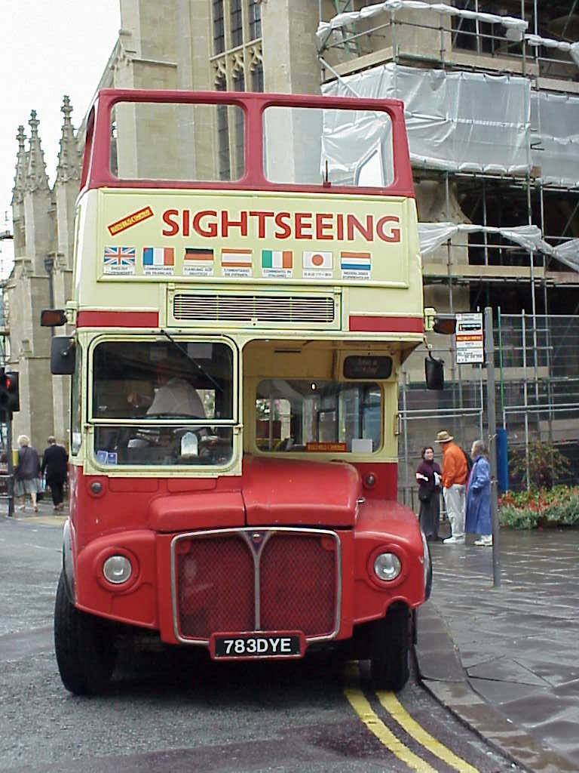
Travel Journal
UNITED KINGDOM SEPTEMBER 2000

Tuesday 29th August
London
Weather: Sunshine
Quote of the day: “Icarso Ore mi attata, ba wo ni?”
I arrived from Lagos after a restless flight, with a Nigerian man snoring all the way to London. After no problems clearing customs, (There wasn’t even anyone there to check your bags in the ‘nothing to declare’ line) I headed over to the station to catch the train to London. The first train arrived, and was so full, there was no way I could fit on with my suitcase, so I had to wait another 20 minutes for the next train! Welcome to England! The other shock was the fare, at L9.50 I thought it a bit steep, but I didn’t realise just how far I had to go, I thought Gatwick airport was closer to the city. When I arrived at Faringdon station, all I had was a mud map I’d downloaded from the internet which made it look like I didn’t have far to go for the hotel, so I decided to save on a taxi fare and walk it. The trouble was, I couldn’t find the hotel on the map, and the street it was on was not shown on any of the other simple maps I had, so I wasn’t exactly sure where it was. A parcel delivery man appeared, and they always know the streets, but asking him didn’t help; he’d never heard of it either! So I was beginning to wonder if this hotel actually exsisted, or whether I had got it mucked up. I knew I was in the right area and so kept walking, until eventually a man saw me looking at my maps asked where I was headed. “Oh sure, I know where the Thistle Barbican Hotel is, in fact I’m walking that way myself.” So he showed me where to go, and directed me down the right street.
Half way down the street, I saw Dad who was walking the streets looking for me. They had come to London to join a bus tour of the UK which was handy as I wasn’t going to Australia this time. Everyone was happy to see me, and thought I must have been kidnapped in Lagos, as they thought I would have been there hours earlier!
After getting sorted out in the hotel, it was time to hit London! We headed over to the tube station nearby, and went down to Leicester Square where we walked around taking in the sights, despite being tired. We then headed down to Piccadilly circus where we stopped at Burger King for lunch, my first junk food fix in 6 months!
After lunch we made our way down Regent Street, and onto “Hamley’s” toy shop; the biggest in the UK. Mitch and I made a bee line for the model train stuff. We later went back down to the ground floor where the others were watching a man (who just happened to be black) demonstrate one of the toys so that people will buy it. But he looked up, when a black lady near the door was leaving the shop, and he waved to her and said “Odabo” which is Nigerian for goodbye. Without missing an opportunity to practise my Nigerian, I spoke back to him saying “Icarso Ore mi attata, ba wo ni?” (Good afternoon my very dear friend, how are you?) He looked up in stunned amazment, nearly falling off the box he was standing on! “How can you speak like that?” he asked. “Because I’m Nigerian” I replied, opening my wallet to produce a bundle of Nigerian N50 notes which happened to still be there on account of me just arriving that morning. Well, this stunned him even further as he hadn’t seen Nigerian money since leaving there years ago. I spoke some more with him while my stunned parents looked on, Dad with the video camera out to record such a bizare account, then I said Goodbye to him, as he complimented me on how much of the local language I knew.
Later we took a walk in St. Jame’s park, saw Big ben and headed back to Leicester Square. Mum and dad went back to the hotel as they were going to a show that night, but us with nothing on, decided to take the kids to the pictures. We don’t have cinemas in Nigeria and so miss out on finding out on what movies are even out or on at the moment. It just so happened, that the Flintstones movie was playing, and the boys where very keen to see it. “So 2 adults, and 2 childrens tickets comes too…. What! You must be joking… 25pounds!!!” I said as I reeled back from the ticket window. (That’s like $65 Australian!) The movie was cornie and I kept whispering to Anita through the whole movie… 25 pounds! Sob, sob…
After the movie, we had pizza for tea at a cafe in Leicester Square where Riley was so tired he went to sleep at the table, so on the tube train back to hotel, and off to bed!

Wednesday 30th August
London
Weather: warm sunny around 20 degC.
Quote of the day: “How much further to Harold’s?” Mitch.
Boys woke up at 5.30am, so we were well ready by the agreed meeting time of 7am to meet Gran and Grandad in the restaurant. Because they are booked in the hotel with a bus tour, they get to eat continental breakfast in the restaurant free. But nobody checks who is who, as normally other guest wouldn’t know about the special breakfast dining room, but seeing that we do, we tag along also!
We caught the hotel courtesy bus to “Old Street” tube station, then took the train down to St. James station, walked through the park and onto Buckingham Palace. The sign said changing of the guard at 11.30, which was more than an hour away, but it was decided to wait anyway. So we sat and watched the policewoman on her horse bossing people around until about 11.15 a marching band left the palace for a trip down the street. There was some more marching around, and some yelling at the subordinates, while the replacement guards arrived, so it was good that we had stayed and not just come back for 11.30. “Why do the guards stay so still?” Riley wanted to know. So I explained that our guards at home are just as motionless, to which Anita had to agree! (They just make more noise….. Zzzzzzz!)
So eventually the marching band came back, with fresh guards who eventually did the shift change over and marched the tired ones back. All fascinating as you can imagine! We then went and took a photo of Queen Victoria, who Mitchell is very interested in as he learned all about her at school, because the school is actually English, which Mitchell says “We are not amused.”
We then trekked down through Knightsbridge to Harrods. It was quite a walk, and Mitch kept asking, “How much further to Harolds?” We found Harrods much to posh and expensive for lunch, and so we found a nice café style restaurant across the street which looked just the ticket, so after we had a light lunch each and paid L55 ($145) we remembered just how expensive this damn city really is!
After lunch, we walked further down past the Victoria and Albert museum to the London science museum, where we spent the afternoon looking at steam engines, marine engineering, the history of medical science and took Mitch through the aircraft hall. All fascinating, and almost exactly as I remember it from 1990.
Back on the tube home to the hotel, as we were all too tired to stay out for dinner. But the hunger pangs, saw us head down the street to a little pub, The Brittania Hotel where we had a simple meal of chicken and mushrooms with rice for L4 each and a pint of lager. Home again and straight to bed at 9.30.

Thursday 31st August
London
Weather: sunny 20 degC, cloudy afternoon with strong wind in evening.
Mitch woke at 6.15am, while Riley slept in which surprised us, but we later found out he has a sore throat and stiff neck and is running a bit of a temperature.
Riding on the tube for the third day in a row, we headed out to North Greenwich to the Millennium dome. Very impressive, and hardly crowded. When we first arrived we found the British Telecom stand with free internet access, so we jumped on a PC and checked our e-mail. There were 10 waiting in the inbox! 2 of them were from Pretty Girl, who is settling well at Vonda and Ross’s place at home. We wrote a reply to her, then e-mailed Grandma and Grandpa who wrote to say Mitchell left his watch in the bedroom.
Next we had a tour through the human body, saw a machine which made pencils from recycled styrene drinking cups and lots of other interesting things. One of the highlights would have to be the show which was on the stage in the centre of the dome, which was very spectacular with acrobatics and people coming down from the roof on wires, all very exciting!
We went outside onto a courtyard area and stood on the Meridian line, and Mitch had stood on the West and Riley on the East and I took there photo shaking hands across the line. We then turned on the GPS, which just happened to be in my pocket and checked in out. It said the Meridian line was 30 metres further over. So who is right? Is the GPS out a bit (most likely) or is the line painted on the ground in a convenient spot to fool the tourists? I took a photo of the GPS showing zero on the East/West axis just for wank value.
Back inside, we had a tour through space, learned about the power of talking, learned about water pollution and water wastage, saw how transport would look in the future, and what lay ahead for computers. It was all very good and we spent 10 hours there. Being so tired we decided to check out the relaxing room, which was like a giant igloo where you lay on your back on the sloping floor and looked up at lovely colors being projected onto the ceiling, with very soft chime type music playing. You had to be still and silent and it really was very relaxing. Riley went to sleep, and I almost did too. After MacDonalds for tea (well it keeps the kids happy) we headed back via the tube to home. Even with his sore throat and stiff neck, Riley still walked 100 miles today, he was just very quiet, and never complained once! He really is amazing.
At the hotel, we got cleaned up and went up to Gran and Grandad’s room to see them off, as they head off on their bus tour tomorrow, and we pick up our hire car and head West to Dorset.

Friday 1st September
London to Bournemouth
Weather: cool, cloudy with afternoon rain periods, 17 degC.
Quote of the day: You don’t feel so ripped off once you get out of London and find a real supermarket. Anita.
After breakfast, Mitch and I walked the few kilometres to Russell Square to pick up our hire car. We navigated by GPS, so we would be sure to find our way back, a good plan at the time. Once we found the Hertz office, we thought we were back in Nigeria, as 2 of the 3 staff were black! (I think there are more black people in London than in Nigeria…) After a long wait in the cue, as there were about 6 other people ahead of us, we sorted out the paperwork without any hassles, then went to the carpark below to pick up our car, but when we started the engine, we discovered the tank was empty, so the manager, sent his black mate down to take us over to the servo and fill ‘er up! So my newest mate, all the way from Ghana West Africa drove Mitch and I in our brand new Ford focus with only 4000kms on the clock, like a little laser with a fast back, round the corner, up the street, across the way, and round into the servo where he filled the car. (He was surprised when I told him we were from Nigeria.) He then said your right to go. “But don’t you need a lift back?” “No…” “So where are we????” So much for tracking back from the office with our GPS!
We gave up on tracking back, and just asked the GPS to direct us to the hotel, only with the tall buildings, it kept loosing the satellite connection, so often we were flying blind. Then it kept telling us to turn right, but the right turn we made took us up a dead end street! Then all the streets after that were “no right turn”. How frustrating!
We finally found the right street, so it did get us there in the end, and I had no idea where to go. Not until it said straight ahead and 200 metres to go, that I realised we were in the right street and could see the hotel ahead.
Next we checked out of the hotel and loaded up and realised the little car has only a little boot, hence, room for one suitcase out of 4, plus a little extra for our ‘Ghana-goer’ bag. So we had to organise with the hotel to store 3 of our suitcases before we headed out of London. Only thing was, we didn’t bank on the traffic moving so slowly, starting and stopping (more stop than start…) and again we used the GPS to guide us in the general direction. After traveling 1 hour, the car trip meter told us we had traveled a staggering 13kms from the hotel! What progress!!!
Eventually we were on the open road, and heading down the A3 to Portsmouth. We called off the main road to Petersville where we found a real live supermarket! So we stopped in the pouring rain, ran in and brought some fruit, and rolls for lunch. After not seeing a real supermaket for so long, we were all excited at the range of fruit available, and so cheap too after London! Back on the road with bread roll in one hand, banana in the other, grapes in my lap and steering wheel in the middle, we detoured off at Winchester across to Southampton to attempt a visit to the restored passenger ship SS Shieldhall. After getting lost only twice, we found gate 4 into the docks, only to have dock security tell us there was no way he would let us in, as it was a private dock area and not open to the public. So even though we could see her in the distance, that was as close as we could get. Even pleading that I had driven all the way from Australia, and was restoring a ship with the same engineroom did no good.
On the road again, still raining and into Bournemouth by 5.30pm. The hotel was easy to find as our voucher from home had directions which made it easy. The hotel was old 60’s style, typical English seaside but all very comfortable, even if the room was a little cramped. We settled in, then drove around the sea front trying to get orientated. I took a photo of the pier through the pouring rain, then looked around for one of the rarest things in the whole UK…. a parking spot!!! Unable to find one within walking distance of any shelter, we abandoned the eating out plan in favor of going back to the dining room at the hotel. I had a lovely mixed grill washed down with a pint of cold lager! Anita had the lasagne, while the boys picked something off the children’s menu. Off to bed now, we are tired again! Tomorrow, Dorset steam fair!!!

Saturday 2nd September
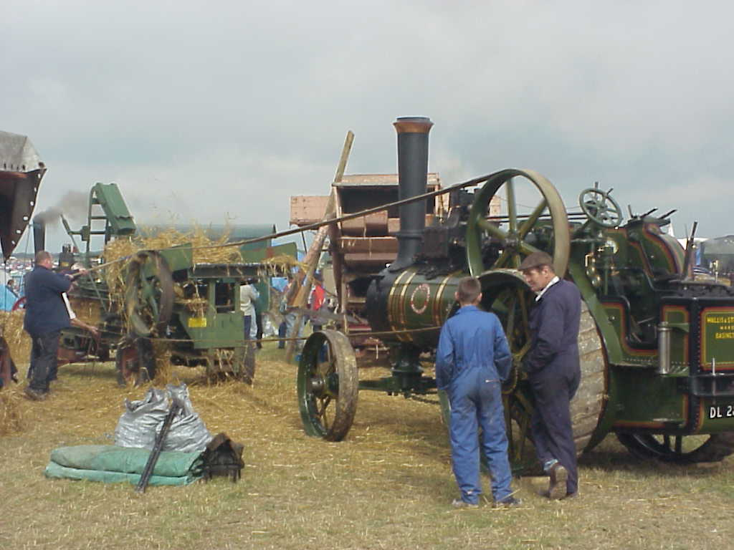
Great Dorset Steam Fair
Weather: cool, cloudy with sunny patches, 17 degC.
One thing the British are good at doing, is Cueing. I am still learning, but getting the hang of it! After breakfast, Mitch and I hit the road at 9am for the Dorset Steam Rally, the very event that led us to take our holidays in the UK during September. After getting through Bournemouth and out through Poole, we settled into a lovely drive through the country, past some quaint little villages and straight into the longest traffic jam in history! As far as the eye could see, was a stream of cars disappearing over the brow of the hill far ahead, and only a skinny little road with no where else to go. At least everyone else was in the same predicament, and nobody bother to try the old “I’ll whizz in front and be one space better than you” trick. Everyone was very calm and just coasted along in first gear. At times I think we were moving at walking pace with lots of stopped time in between hence it would be quicker to walk. At least we had a decent radio station to listen to while waiting, and they even had a traffic update, telling us the road to the Dorset steam rally was bumper to bumper and hardly moving. Yes, we were all headed to the same place. The trip ended up taking 1 hour 50 minutes, and only 35 minutes to come home again at the end of the day via the same route!
The rally was sensational! I didn’t know so many “Burrell” scenic showman’s engines exsisted, let alone see them all gathered together. The show was dedicated to Charles Burrell of Thetford in Norfolk, one of the more popular builders of traction engines. There was also many other makers represented as well. We saw shire horses going through there paces in the heavy horse arena, where a beautiful black animal was declared the winner of the show, after he successfully paraded around the arena, demonstrated backing up, turning sharply and then taking his place in the line up, all executed with gentle precision; it really was great to see!
We also walked through all the chinsey junk stalls, with many bargains catching my eye, but transport difficulties reminded me to leave it there! The amusement rides too were a bit chinsey and didn’t really fit in the rally picture I imagined.
There were great displays of heavy haulage vehicles, trucks as well as steam. The heavy haulage arena was shaped like a light bulb, with the top neck disappearing up a 1 in 12 grade, and I was impressed to see a very heavy army tank, on a low loader with 3 traction engines pulling from the front, and one pushing from the back to get the load up the steep hill! There was also a “Scammel” heavy haulage tractor pulling a 200 ton low loader, with another pushing from the back, all very impressive.
Mitch liked the stage show, which was set in front of a large Gavioli fair ground organ, with a lady singing on a microphone, then these young girls dancing around, and a magician act. He like it so much, he wanted to see the next performance while I walked around the line of showman’s engines all generating away running the various amusement rides behind them. We also saw a steam merry-go-round, which reminded me of the one I did the boiler engineering work on before going to Nigeria. (It should be going on the Geelong waterfront by now.)
After a good day out, we headed home to find Anita had spent the day catching up with the washing, then her and Riley went down and spent some time on the beach. Dinner in the hotel bar, followed by bed for all! Still feeling tired, but catching up!

Sunday 3rd September
Bournemouth
Weather: Sunny!
Headed out to the Great Dorset Steam Fair for the second day, and found a whole lot of stuff I hadn’t seen yesterday, including a great collection of vintage motorcycles, vintage trucks, tractors and internal combustion engines, with a great selection represented. (No Jellbart tractors though!) We also saw more of the steam heavy haulage, and watched the steam ploughing which was taking place in the large field next door.
We left the rally mid afternoon so to meet with Anita and Riley, and take the boys down to the beach. Anita told me she saw a lovely paddle steamer going past in the morning while she was at the beach with Riley. I wondered if it could be the famous “Waverley” the world’s last ocean going paddle steamer? We chatted with a young lady on the beach, who was a primary school teacher from Switzerland who had come to England to practice her English before embarking on a holiday in Australia, so she was very interested in us. (Or maybe she was just keen on me….)
When we returned to the hotel just down the street to get cleaned up for dinner, I looked out the brochure on the travel itinerary for “Waverley’s” summer cruises, and sure enough, she was at Bournemouth pier that day, and I was surprised to see she was returning at 6.30pm to take out another cruise down through “The Solent” between the mainland and the Isle of Wight, to Southampton that evening. Checking the time, we had 10 minutes to see her! As we couldn’t afford the L13 per person to do the cruise, I had to be content to just see her. We all rushed back down to the lookout over the beach, just in time to see her pull into the pier. She waited along side for 10 minutes, then took off like the greyhound she it, towards the Isle of Wight. It made my day to see her passing!
We then headed down town looking for somewhere to eat, as we were sick of eating in the dining room at the hotel as we had done the last 2 nights. We found a couple of great looking pubs, but they threw us out because the kids where not welcome. The restaurants didn’t look like they had anything simple for the kids, and they where starting to complain about the walking and they were hungry. So guess what? We headed back and had dinner in the hotel dining room again!
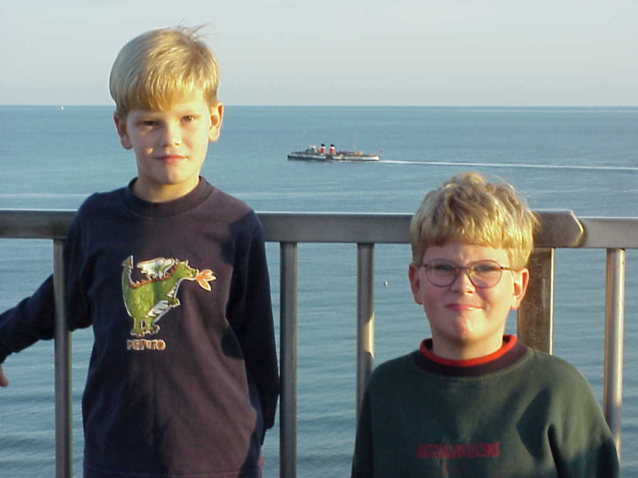
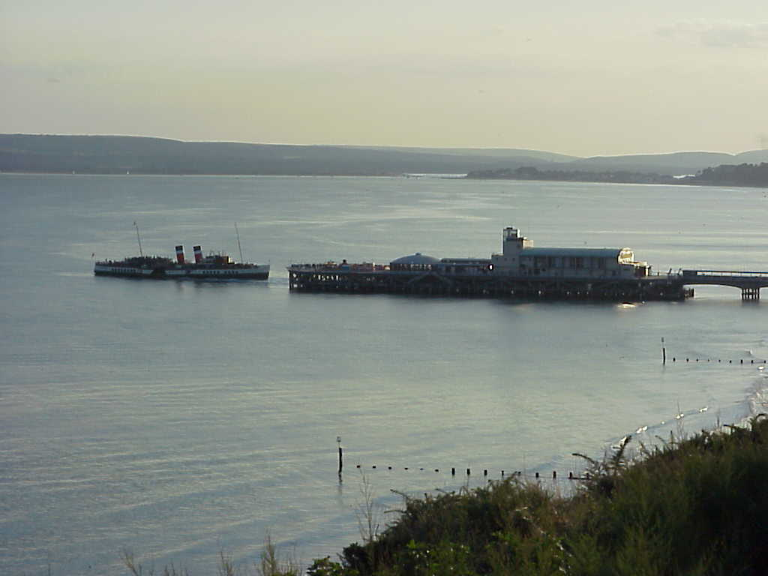
Monday 4th September
Bournemouth to Bath (Somerset)
Weather: sunny, 19 degC.
Quote of the day: If you are having trouble with the GPS Mum, give it to me, I like to use the latest technology. Mitch.
Packed up the car and headed out of the car park, then we traveled all the way to the street outside the hotel, where I stopped the car and said to Anita, who was holding the map “So where are we going?” We to and froed with a few ideas, (I cant believe we had left it to this point to decide) and finally agreed to head off to Monkey World for Mitch and Riley to see the monkeys. There we saw Orangutans, chimpanzees, spider monkeys, woolly monkeys, and ….. rabbits.
We had seen enough by lunchtime and so hit the road again, traveling the very same road Mitch and I had traversed the past 2 days on the way to the steam rally. At Blandford, the nearest main town to steam rally, we found a Tesco supermarket where we stopped and brought, bananas, Marmite, peanut butter, bread rolls, grapes, carrots to munch, and ….. (of all things…) a colander for the kitchen as our old one of Bonny wants to be repatriated to the Bannockburn tip near Geelong. (It’s paying its own way home…)
We then drove down some lovely country lanes, through some very pretty little villages, with stone churches, thatched roof cottages, and green fields. We can’t believe it’s the end of summer yet the fields are all still green! (They would normally be burnt off to yellow/brown by that time at home.) We were desperately seeking somewhere to stop and gorge ourselves on the bounty acquired from Tesco, but alas it wasn’t so easy to find. So out of desperation, I turned up a tiny little lane, then pulled up in the first drive way of a farm house which had like a triangular bit leading back onto the road with a little tree in the middle, where we sat for our lunch. Mitch was worried the farmer would come along and not be able to get in. Just across the road was a pheasant searching in the bushes for his lunch. I grabbed the closest thing to a shotgun, the camera, and took after him trying to shoot him before he got away. It was reminiscent of a similar incident 10 years ago in Bakewell where I also chased a pheasant across the Dales with the camera, only to have him get further away as time went by… who says history doesn’t repeat? The same thing happened, he just got more worried and the distance between us grew larger. I gave up. Just behind where we sat for lunch, there was a gate leading to a bridleway across the paddock and up over a lovely green hill. I think these bridleways are free access to enter and ride your horse through, or walk. It brought back memories of the Isle of Wight where Anita and I while walking through a paddock, stopped on the side of a green hill with a great view which we sat to admire. Eventually we lay down and closed our eyes. When we opened them again 10 minutes later, we were surrounded by a whole herd of Fresian cows looking at the mysterious visitors to there paddock!
This dream was shattered by, as predicted by Mitchell, the farmer coming round the bend to find his driveway blocked! We moved the car and let him in. He was quite nice and told us to stay and enjoy, but it was time to move on anyway.
We drove on through more villages, stopping occasionally to take a photo of an interesting building here and there, (I am doing black and white photography on Bonny and it is difficult to find subjects to photograph, so I am making the most of opportunities that arise!) and on towards Bath.
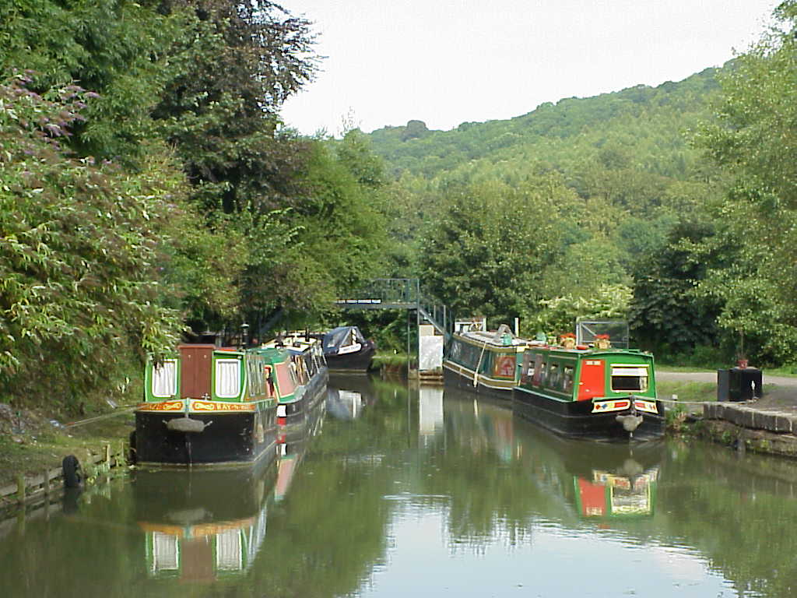
We found a little tea room beside the Kenneth and Avon canal, where we stopped for tea and more photos. A shop there called “The Titfield Thunderbolt” sold railway memorabilia, where I brought the video of the movie “The Titfield Thunderbolt” one of the favorite movies around the steam rally circuit. The man in the shop told me the film was actually made right there! After tea and a walk along the canal to see and photograph the aqueduct built in 1790 we headed into Bath. We were again surprised to see the beauty of this great city, establish by the Romans around hot mineral springs where they set up Roman health and relaxation centres. I remember being surprised 10 year ago when we arrived here. We found a B&B, had tea at the pub then found a great adventure playground for the boys. After playing until dark (8pm) we decided to have a drive around the city light of Bath. After we had seen enough, Mum fired up the GPS to find our way home. First she pushed this button, then that, but she still couldn’t figure out what it was telling her. “If you are having trouble with the GPS Mum, give it to me, I like to use the latest technology” Mitch told her, so she passed it over to the back seat, and it was passed back to the front with our home destination programmed in. (That’s my boy!) The trouble was, it said only 800 metres to our hotel, and directly to the left. So we took the next street to the left, and wound up in a dead end inside the bus depot! The boys cracked up laughing!!! So out onto the road again, and the next turn left took us to the carpark of Computer World! They laughed at me again. (Damn technology!) The next turn left was better, than the GPS told me to turn left again, and bingo… only 300mtrs up the street there was out hotel. Mitch knew the modern technology wouldn’t let us down! Mum and I are debating about Bath, and I think we have decided to have a full day here tomorrow, and stay another night before moving on to Wales Thursday.

Tuesday 5th September
Bath (Somerset)
Weather: cool with light rain patches in the morning, a light drizzle afternoon..
Quote of the day: “Cheer up old fellow!” (With strong, posh English accent)
After a lovely full English breakfast, we hit the streets of Bath on foot to head down to the gardens about 1 kilometre from our B&B towards the city, in an attempt to catch the city open top tour bus. The problem was, it started to rain lightly and we didn’t have our coats or umbrella, but it wasn’t too bad. We followed the little mud map from the tour company, showing the pickup point in the Victoria Gardens, named after Princess Victoria who visited Bath in 1812ish. We soon got lost, and Anita asked an older man outside a beautiful mansion, trimming the hedge, where we were supposed to be. He gladly gave us directions in his plum mouthed posh accent, then looking at Mitch who had been complaining about walking all the way, said “Cheer up old fellow!” He said it in such a positive and funny way, it made us all laugh, even old grumpy pants Mitch!
We found the bus stop and hopped on, then went into the centre of Bath where we got off again. The tour guide didn’t stop to draw breathe all the way between talking about all the facts and figures of Bath. He was even talking about the unofficial King of Bath, Bo Nash who Anita’s grandmother claims was her great grandfather.
We looked through the beautiful Bath Abbey, which impressed Mitchell the fact it was built in 1499, and we saw the Roman baths (from the outside). We were going to take the boys inside but as Anita and I had already been in there, and is was going to cost L22 we gave it a miss. We brought a bike light for Mexico’s bike, and some other goodies, found a petshop which sold things for bird brain, like seed, some chewy hide things for dogs that the lady said should be good for parrots, some sanded perch covers and a new water container which she can’t attack and throw around the bottom of the cage when she is in her funny mood (every 28 days… typical women!)
We had lunch beside the Pultney Bridge, which is one of only 2 bridges in the world that has shops on it. Lunch consisted of pies that we brought 3 for one pound, plus some more carrots, bananas and apples from the Tesco stash from the day before. Than back on the bus to complete the city cycle for the Bath tour. We passed all the beautiful building, past the posh circus houses (not with elephants in the yard, but built around a circular street with a grass bit in the middle) back over Pultney Bridge, then we got off again and had a nice afternoon tea of scones and cream in an little café. Then on the bus back to the gardens where we got on, walking home past the adventure playground where Mitch and Riley had a play, then back home to get cleaned up for dinner.
We had dinner at a pub beside the kennet and Avon waterway, where canal boats can tie up and dine, just out of town. We sat in a glassed in conservatory drinking big pint glasses of John Smith’s, over a nice meal. Then home to pick up the washing bag and round the corner to the Laundromat for an entertaining evening watching the dirty jocks going around and round in the little porthole, before heading home for bed.
Anita rang Gloria, who lived with us on Bonny, but is now in North Wales, and we are hoping to see her Thursday night, after spending Wednesday somewhere mid Wales.

Wednesday 6th September
Bath to Aberystwyth, Wales
Weather: light persistent morning rain, followed by cloudy afternoon, 17 degC.
Quote of the day: “Yes it is a rip off!” -Severn River bridge toll collector.
Left Bath in light rain, towards Bristol. Anita is ill with a bad sore throat, swollen glands and high temperature. We drove through the traffic of Bristol, stopping at Sainsbury’s to get some Disprin and Strepsils for Anita. We drove out of Bristol on a lovely motorway, making good progress until, with no chance to turn back or around, we found a big sign saying “Bridge toll L4.50”!! Surely for a little car it couldn’t be that much? It was the big bridge over the Severn River, taking us from England into Wales. It was impressive, and it was L4.50! It was in the mood for an argument, and so told the toll collector it was a rip off. He shot my argument down in flames by agreeing with me! "Yes you’re right, it is a rip off, pay up!”
We drove on through some lovely scenery, with Anita dosing off in the passenger seat, and not at all well. Passing Mertha Tydfil, the birth place of my Great, great Grandfather, and on through other little villages following the river Wye. We had lunch in a little park, and also stopped at a water powered corn mill, “Felin Newydd” which was over 200 years old. Meaning “new mill” in Welsh, it has an overshot water wheel 12’ in diameter, which can produce 5 horsepower to power the grinding stones.
We were trying to make Porthmadog (pronounced Portmadock) but with us all feeling sick on driving on the narrow windy roads, and Anita still not well, we stopped at Aberystwyth by 4pm. Anita went straight to bed, while the boys and I explored the
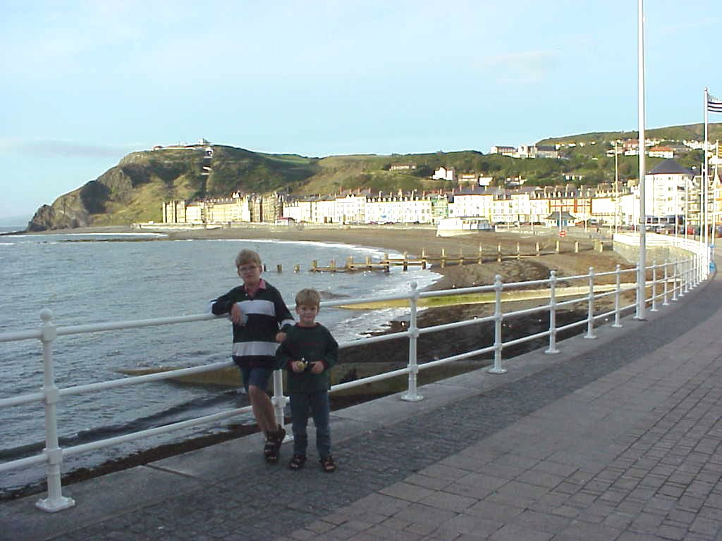
remains of the castle, and played in the playground until tea. Anita was still sleeping and not wanting any tea, so the boys and I walked into town for pizza, ice-cream, then home to bed. Anita slept in the single bed, while Riley slept with me.

Thursday 7th September
Aberystwyth via Porthmadog and Betws-y-coed to Llangollen, Wales
Weather: light persistent rain, mist and fog in the high country, 14 degC.
Quote of the day: “Boy you see castles like McDonalds around here.” -Mitch
Anita still has swollen glands and inflamed throat, although the fever seems to have gone, so we attempt to find a doctor in Aberystwyth before setting off. The B&B lady turns out to be a Perth girl, who married a Welsh sailor in Australia and has settled in Wales. She misses the weather of Oz (and we are about to see why…). Her husband is a shipping nut like me, and has a huge collection of shipping paintings, photos, and memorabilia scattered around the dinning room and hallway, and so after a long chin wag with the lady about ships and Oz, she directs us to the nearest doctor, which is a bit of a drive away, and we get lost again. I asked directions at the local supermarket in the area where we were supposed to be, and the man pointed to a building almost across the road, and said “That’s it”. So we weren’t too far out.
The bad news, is it took 1 hour wait to see the doc, with the kids and I waiting in the car, the good news, they have an arrangement where Australians are treated free, because the English are treated the same in Australia. The supermarket across the road has a pharmacy where we fill the prescription, and stocked up on our lunch stuff, more carrots and rolls, strawberries, cherry tomatoes and some little apple tarts for our treat.
We finally head off at midday North towards Porthmadog (Portmadock) in the light drizzly rain which has not let up since we set off in the morning. At around 1pm, Mitchell’s stomach worms are biting so much, we stopped at a little roadside area, which has picnic tables, and some bush walks which would have been tempting except, even though the rain has stopped, the view the whole way has been non existent, due to the thick fog we have been driving through. The roads too are a nightmare, being so skinny that at times you have to stop to let the trucks pass! So a break was truly earned all round.
More long driving on the windy narrow roads around Wales, and we are all thinking, we are spending too much time in the car, and not enough out enjoying ourselves! Finally we arrive at 3.30 at Port Meirion. This is a special village set up by Mr. Clough-Elles to be the ideal picturesque village. Nobody lives there, but it really is beautiful. We visited here 10 years ago, and as Anita has the dinner set designed by the same chap and we wanted to buy more pieces. So we headed into Portmadog to find the gift shop. We passed the Ffestiniog Railway, as we entered the town, and as it was a must on our ‘to see’ list, we stopped, only to find the last train had left for the day. So onto the gift shop where Anita bought a vase and some candle holders to match the dinner set, and I brought a Welsh miners lantern. I had always wanted one since seeing them 10 years ago, and after waiting so long, finally bought one! (You know how I love kerosene powered things…)
Off we set again, heading back the way we came, then turning off on the road to Betws-y-coed, then once reaching there, Anita wanted to stay, but I talked her into moving on to Llangollen, which was only another hour down the road. We pulled into the first hotel we saw, which looks quite posh compared to the B&B we stayed at last night, but we are tired and sick of driving! There is so much to see and do in Llangollen, that we are looking forward to the steam railway, and horse drawn canal barge trips tomorrow! So, down to the restaurant, 2 pints of McCafferies and Beef stew with Yorkshire pudding for dinner, then get the kids to bed!
Friday 8th September
Llangollen to Hawden (Chester), North Wales
Weather: cool and cloudy with no rain.
After sleeping at the ‘Wild Pheasant’ hotel, we headed into Llangollen town centre, parked the car and headed over to the steam railway. (For Mitch and Riley, of course.) The train was due to leave at 11.15, so Mum saw us off and headed for the shops, while the boys and I bought a ticket and waited for the train to leave, admiring the engine and taking a few photos before departure.
At 11.15am sharp the train pulled out of the station and headed up the line following the fast running river Dee, over a couple of picturesque stone bridges and through a long tunnel, stopping at a couple of stations along the way. Only one man got off, loaded with his bags of weekly shopping, everyone else were tourists and stayed on.
At the end of the line, we watched the engine run around the train and couple up at the other end. After a short wait we headed back to Llangollen, where Anita was waiting with her recently purchased goodies, including a “Guinness Draught” rugby top for me!
After the train, we headed up the hill to the horse drawn canal boats, where we boarded for the 45 minutes return journey up the canal. A very peaceful journey with the clip-clop of the horse and lapping of the waves the only sounds outward, and Riley winging, complaining, and making persistent annoying noise all the way back!
We brought some rolls for lunch and drove out beside the canal towards Chester, parking beside the Ponty-thingo canal aqueduct, which is 122 feet high, and had a canal boat passing over the top when where there, making a good photo opportunity for our lunchtime entertainment.
Moving on we arrived just South of Chester and just inside the Welsh border at Mike and Gloria’s place by 4pm. Mike was home, but Gloria was out shopping for their eldest son who was off for 2 weeks in Spain, after purchasing a last minute cheap ticket only hours before. The only trouble was, he was flying from Birmingham airport, 100 miles away and needed a lift that night!. So Anita and Gloria caught up, while Mike and I drove Craig to the airport in Birmingham, a 2 hour drive away, leaving at 7.30pm and getting back to Mike’s local pub just before closing time at 11pm. I quick pint of “Tettely’s” then back home, where the girls where still up talking. We all sat and talked, drinking some lovely wine, then a coffee, finally retiring at 3am!

Saturday 9th September
Chester, North Wales
Weather: Cloudy, with spitting rain in the afternoon.
We left Mike and Gloria’s in the morning after breakfast, towards the shopping centre Gloria had directed Anita too. We spent far too long looking at clothes and buying up big, with Anita getting excited after not seeing shops like these while living in Nigeria. We finally got away from there close to 1pm, and took the ‘park and ride’ bus from the zoo carpark to the city centre in Chester, which turned out to be a very wise move once we saw the traffic, crowds, and limited car access in the narrow Chester streets, many of which were closed to cars.
After a quick lunch at old faithful Burger King, which wasn’t so quick with the long cues waiting to be served, we headed out into the mayhem in the streets. We haven’t seen so many people since leaving Nigeria! We also walked around the city walls, completing a full circle of the Chester inner city centre, stopping at the canal, to admire the construction of the lochs on the “Shropshire Union Canal”.
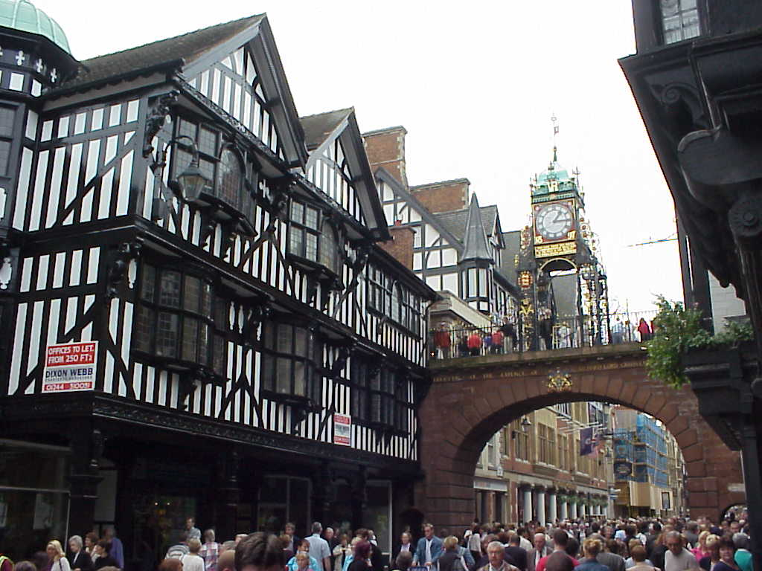
Anita had arranged with Gloria to meet at the hospital where Chris is staying. Chris, you may recall, visited Bonny Island last Christmas, and dived into the pool at the JV camp, leaving him a quadriplegic. This is why Gloria has come back to live in the UK and her and Anita had so much catching up to do. The boys also enjoyed the time they spent with Laura, who went to school with Mitch, as she is 1 year older than him.
We were supposed to meet at the hospital by 4pm, but it was closer to 5.30 when we arrived. Gloria had arranged a hotel room for Mike and her, as well as us just up the road where we stayed. The new hotel had only been opened 2 days, and so everything was brand new and smelling of fresh paint.
We had a lovely pub style dinner in the restaurant, before retiring to the lounge bar for a few more pints of “Theakston’s” bitter, you know, the one they have to pump up from the cellar with the big handle on the bar. We finished off with some Jameson’s Irish whiskey, to remind me I was going to Ireland tomorrow!

Sunday 10th September
Dublin, Ireland
Weather: Sunny, with partial cloud, 20 degC.
Said Goodbye to Mike and Gloria, jumped in the car and headed off to Manchester for the airport. Dumped the car and caught the 1pm “Air Lingus” flight to Dublin, arriving in Ireland 35 minutes after take off. Those poor flight attendants, only have time to throw lunch at you before you are landing again. (Poor old Mum and Dad came by ferry, and took 3 ½ hours!)
Checked out the hotel where Mum and Dad are staying near the airport, but it was booked out, so we are staying in the hotel across the road. We then went back to Mum and Dad’s hotel and left a message for them, and jumped in out hire car to get our bearing on the city centre. The traffic was bad, and all the crowd from the Sunday afternoon football match were spilling out and heading towards the city too, making progress slow. We found a car park, and then a nice little Italian restaurant and ate Spaghetti and Pizza in the middle of Dublin!
After dinner, we headed back to the hotel, arriving about 8pm and without even going to our room, walked back across the road to see if Mum and Dad where there. They were just coming out the front door of their hotel, and had only just arrived. So we headed back to there room for a cuppa and compared notes on where we had all been. They are doing a city tour in the morning, with a free afternoon. We are planning to do the open top bus tour, as we have a discount ticket from Bath to use, then see about a tour of the Guinness factory in the afternoon, and meet Mum and Dad at 5pm at the hotel. I have been in Ireland for 5 hours now, and still not had a Guinness!!!

Monday 11th September
Dublin, Ireland
Weather: Warm, with partial cloud, 20 degC.
Quote of the day: “I can’t believe I’m in a town surrounded by “Michael Richie”s!” --Mark.
We slept in! We had hoped to be up and on the road into Dublin early, but it wasn’t to be. We are staying at the hotel near the airport, because Mum and Dad are there, and we wanted to see them because we wont do so again until April next year! We got a bad impression of Dublin when we went there late yesterday afternoon, and thought it was because we were in the wrong area, but today revealed we were in the right area, and we were also right, Dublin is a little disappointing. We stopped and had a bite for breakfast in the ‘temple bar’ area, close to the River Liffe, and then checked out the tourist information centre. Nearby was the bus stop for the open top city tour bus, which we then jumped on to explore the city. First stop was the Guinness factory, at St. James gate, so we all bailed out here for the brewery tour.
Arthur Guinness brought a lease on a huge area of land in Dublin in 1769 for 9000 years, and so the Guinness brewery sprung up to compete with many other breweries in the area. Everyone thought he was mad to buy the dilapidated factory when the other breweries were struggling to make it, but Arthur’s unique blend of beer soon became famous and the brewery grew to be the largest in the world. We toured the brewery, and had a couple of pints at the end.
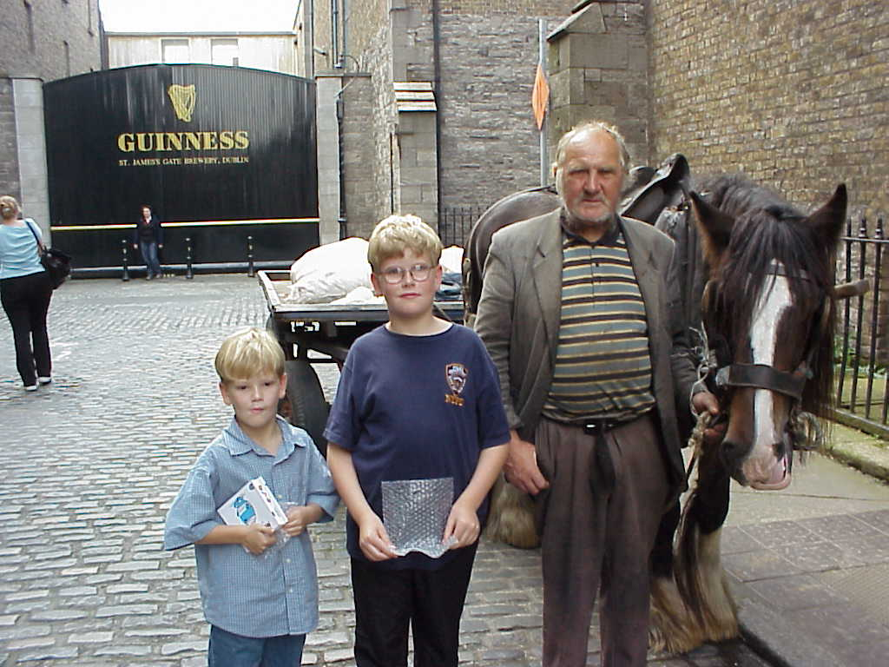
Out the front, we were met by a strange man with a horse and cart who started talking to us as we came out. He asked me how the boys were, then when I asked him how he was he replied “Oh, up and down…” With the 2 teeth in his head, and a strong Irish accent he was quite hard to understand, but told me he used to be a horse handler in the brewery in the days when the beer was delivered by horse. (He was quite old…) I took his photo with Mitch, Riley and the famous St. James gate in the background. He then went on about how things were not the same as in the old days. He really was eccentric, and with a few other strange people we saw in the streets, led me to make the quote of the day, about being in a town surrounded by Michael Richies. Michael is one of the workers on the Wattle, and he too is a little eccentric!
Back on the bus, we saw Christ church cathedral, Phoenix park, the President’s house, and many other interesting sights. Many of the old buildings in Dublin have been either destroyed or knocked down to make way for modern replacements, so we don’t think we will be rushing back to Dublin.
We drove back to the hotel by 6pm, and met Gran and Grandad (Mum and Dad) for dinner at there hotel across the street. They then came back to our room for a cuppa, and we said our goodbyes. They are heading off to the North west of Ireland tomorrow, while we are going due West. We are both having 1 week in Ireland and so may run into each other, but it is unlikely.

Tuesday 12th September
Dublin, Galway, Spiddal (County Galway)
Weather: Cool, drizzly morning rain, cloudy afternoon, 16 degC.
We left the hotel in Dublin after packing up around 9am and headed west towards Galway. Stopped at Kinnigad for breakfast, then headed over towards the centre of Ireland. We drove down some narrow country lanes, until we arrived at our first destination of “Clonmacnoise” an ancient monastery built in 545ad, and ruined by the British plunderers in the 16th Century. The grounds still have the remains of some of the churches and graves, as well as the towers used as look outs against attacks from the Vikings. The entrance to the main cathedral was marked by some typically Irish crosses, the largest central one being the cross of scriptures, which the monks used to educate the illiterate farming peasants about Jesus. To the North and South where 2 other beautiful crosses, (all carved from sandstone). The site still holds significant religious significance, which culminated in the Pope delivering a service there during his papal visit to Ireland in 1979.
We moved on towards Galway, arriving there around 3.30pm. After a visit to the tourist information centre, we had a walk around the city centre then stopped for a cuppa and sticky bun. Galway wasn’t as pretty as we had hoped, and so we headed further west into the Connemara coast area to a small seaside village of Spiddal. We traveled further west to the ferry terminals which take cars over to Aran island off the West coast. We turned around and headed back to Spiddal, and booked into the local pub for the night. After my first pint of Guinness for the day (for medicinal purposes of course) then went up the street for dinner. A walk around the village after dinner to watch the small sailing boats entering the breakwater, then a walk around the cemetery before heading back to the hotel was very relaxing. Another pint of Guinness followed by a dram of Jameson’s Irish whisky before getting the kids off to bed. Mitch and Riley are sleeping in the room next door with Mitchell proudly taking the roll of “in charge of the room”. Mum is worried, but I’m sure they will be fine!
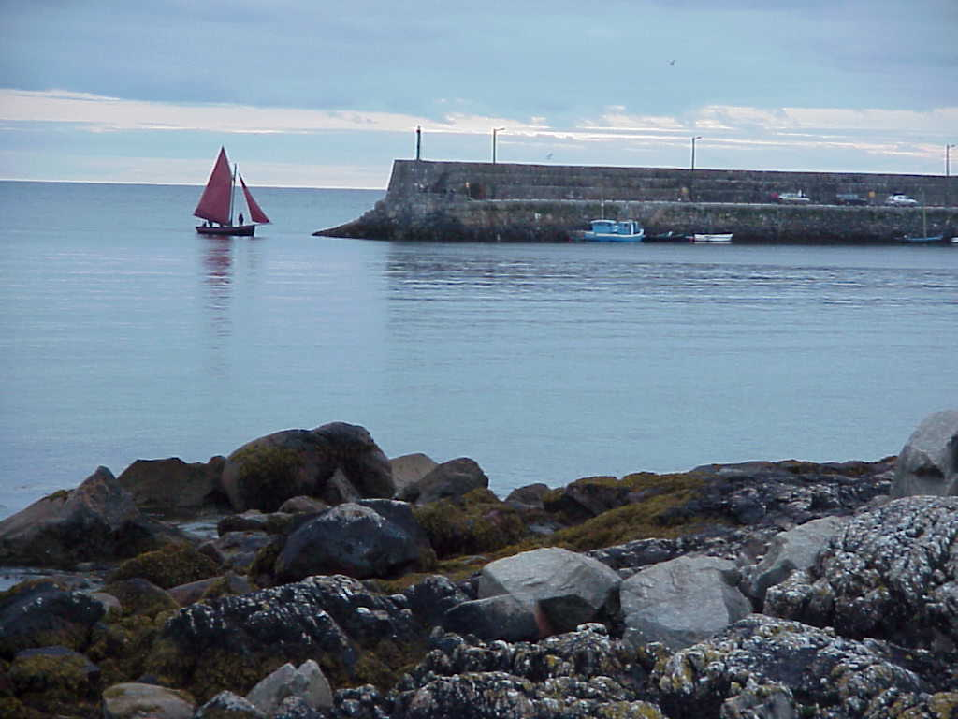
Wednesday 13th September
Spiddal, Limerick, Adare (County Clare) Ireland
Weather: Windy and cold with rain, clearing in the afternoon to cloudy skies.
Quote of the day: “This isn’t what I expected to see in Ireland, I thought I would see the Easter bunny handing out presents” Riley.
We left Spiddal, and headed around the coast to Kinvara, where we saw a medieval castle open to the public. I thought Mitch would like to see it, and as he and Riley were fighting in the back of the car most of the way, it would be good to stop. But they both refused to get out! So Mum and I went for a walk around the castle. It was bloody cold, and I was wearing my coat for the first time this year.
We kept driving around the coast, just as the rain started. Stopping only to snap the occasional photo, and admire the spectacular views across to the sea. There is nothing but rocks and it looks very bleak and barren. I would hate to see it in the Winter. After what seemed like a long drive, we made it to the cliffs of Moher. After seeing nothing for so long, we pulled up in the car park with what seemed like a thousand cars, and walked in the wind and drizzly rain up to the cliffs look out. We were surrounded by hundreds of people, (mostly Americans…) while we took in the cliff views. Mitchell was nearly blown over by the wind!
In the afternoon, we stopped off at Bunratty Castle and folk museum. We were all excited to see the ‘Trafalgar Tours’ bus pull up out the front, thinking we may run into Gran and Grandad, but it was the wrong bus. After touring through the castle, we looked around the recreated Irish village, with several little cottages of similar, but different styles depicting the typical cottages of yesteryear. The castle was built in 1400 and something, replacing one built in 1200 and something. Coming out of the castle, the ground was all wet from the rain which was still drizzling away, much less than the rain we had most of the day. Anita managed to slip down the embankment into the moat on the greasy grass. She didn’t hurt herself, but ended up with mud all up her backside. Mitch was a bit worried, and so after getting up and brushing her self off, Anita asked Mitch “How do I look?” Mitch replied “Your bum looks a bit dirty, but you look perfectly OK from the front”!!!
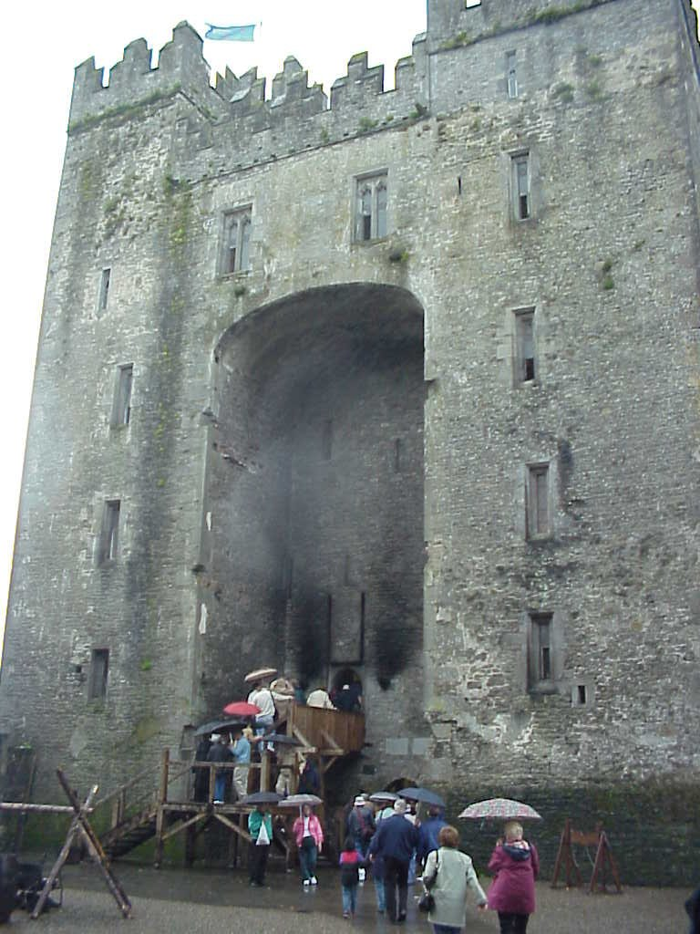
After the boys had seen enough, we headed into Limerick, and started looking for somewhere to stay for the night. Limerick looked interesting, but was made distasteful by the huge backlog of traffic trying to get through the city centre all through yet another collection of road works. Anita was complaining, “Not road works again!” It does seem there is road works going on in every single town in Ireland!
Out the other side of Limerick we found the village of Adare, with many little thatched cottages. We found a guesthouse to stay in, but of course they would only accept cash, as they would have to charge much more if we wanted to pay on credit card which seems to be typical around here. It reminds me of trying to use a credit card in Nigeria!
After a dinner of junk food in the village, we went for a walk around the town. We were looking in the window of the antique shop, when Mitchell sat down on the low window sill of the shop. As he did, all the lights in the whole town went out! So we drove back to the guesthouse, and with my maglight torch, showered the boys and got them ready for bed. The light did come back on 1 hour later, after we had all the work done! Of course we tried to convince Mitch it was his fault, but he would not have it!
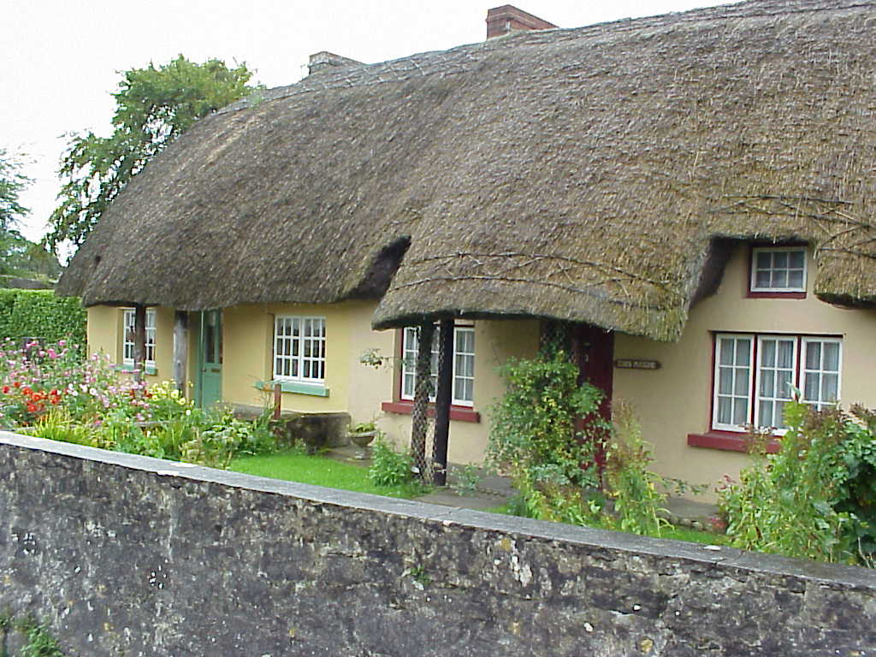

Thursday 14th September
Adare via the “Ring of Kerry” to Killarnie, Ireland
Weather: Cool rainy start clearing afternoon cloudy skies, then rainy evening.
Quote of the day: “Are those kittens stuck together?” Riley.
While looking around the village of Adare, we made use of the post office to send a parcel back to Riley’s mate in Australia for his birthday, while I checked the e-mail. Heading off we drove the narrow windy coastal road of the “Ring of Kerry” with its spectacular and breathtaking views across the Atlantic Ocean. Ireland really is a rugged land, with wind swept, rocky shores and this area is set in front of the highest mountains in Ireland.
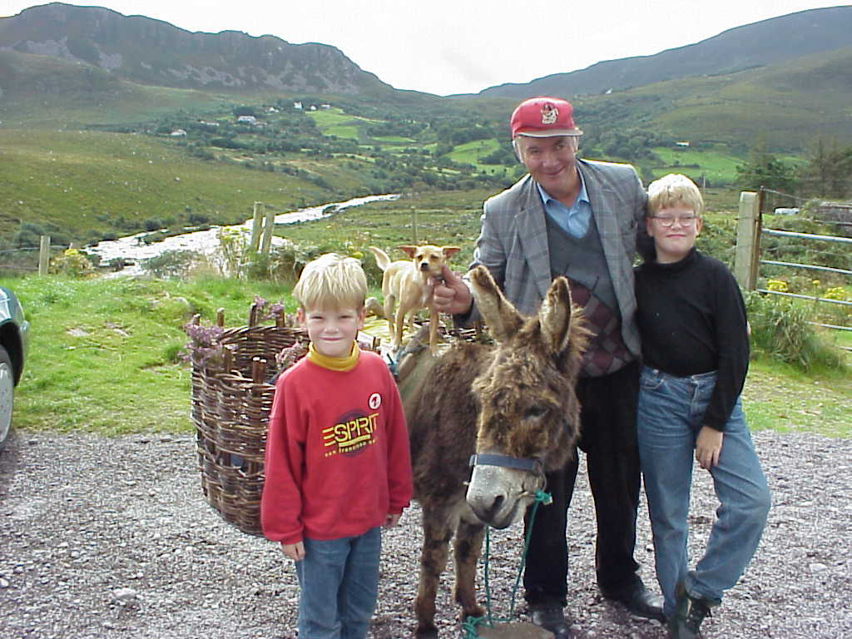
We stopped at several lookout points, which had strange characters hanging around; one with his donkey, waiting for the tourists to photograph him with the great views across the valley behind, then others further on playing there little accordians. At one stop, there was a man who had several tame animals, a baby goat, rabbits and kittens. As it was cold, the goat and kittens where huddled together in plastic crate, just lying there watching the world go by. Riley had been watching the news about the Siamese twins in England, and the controversy about their separation. So when he saw the kittens snuggling together in the box, he asked the man “Are those kittens stuck together?” The man didn’t understand, but Mum and I knew exactly what he was talking about… he is so deep sometimes!
We finally got sick of the windy drive, and took a short cut back to Killarney where we found a Holiday Inn hotel which looked good. We then went into Killarney village to try to find a laundomat without success, then went for a walk to look at the shops, but it started to rain heavily again, so we rushed into a café for dinner and shelter.
After dinner, the shops where still open so we had another walk, and found an old sign for sale, which depicted a steam packet ship, sailing from London to Gibraltar. I had to buy it! So now we are racking our brains as to how we can carry it on the plane, as its too big to fit in the suitcase!

Friday 15th September
Killarnie, Blarney Castle, Cork, Kinsale Ireland
Weather: Cool rainy start clearing to warm afternoon sunny breaks.
Of course having the opening ceremony from the Sydney Olympics threw a bit of a spanner in the works, causing a delay to the start of the day. Anita and the boys where determined to lay around and watch, but I had to put the foot down at 10.00am when the lady wanted to clean the room! So we turned off the tele, and took our bags down and checked out. It was then that the lady told us check out time was 12 o’clock, but I had to insist we get going. Breakfast was required, so we went back into the hotel and had a nice continental breaky before finally hitting the road at 11am.
One of the things bothering me, was the Irish Hauliers association (that’s truckies to us…) were staging a protest at the tax on fuel, which has increased equally with the price of oil. We have been hearing in England, that truck drivers there have blockaded the refineries preventing petrol deliveries, which has almost shutdown England. It had started while we were there but hadn’t really affected us. So now its Ireland’s turn, and they plan to drive there trucks slowly around all the city centres, bringing traffic to a stand still.
So on the road towards Cork, and all going well, until we hit a convoy of slow moving trucks. Luckily they were on a wide stretch of road and were easy to get around without too much delay. So we managed to arrive at Blarney Castle around 12.30. Blarney castle was very interesting, left virtually unrestored. We had a good look around then headed up to the top to kiss the Blarney stone. We have seen photos with a cue a mile long, so we were lucky to find there was hardly a cue to go up and give it a smooch. Legend has it, that the old owner of the castle lent 4000 soldiers to Robert the Bruce for a fight against the English at Bannockburn in Scotland. Ol’ Rob was so grateful, that he gave half of this magic stone to the castle where it was installed in the top of the battlements. It has the ability to bestow eloquence in exchange for a kiss, so anyone kissing it gets the gift of the gab. I guess it works, because Mitchell hasn’t stopped talking since! Mum and I also kissed it, but as you have to turn upside down and hang out under the battlements with a 100 foot drop below, Riley chickened out.
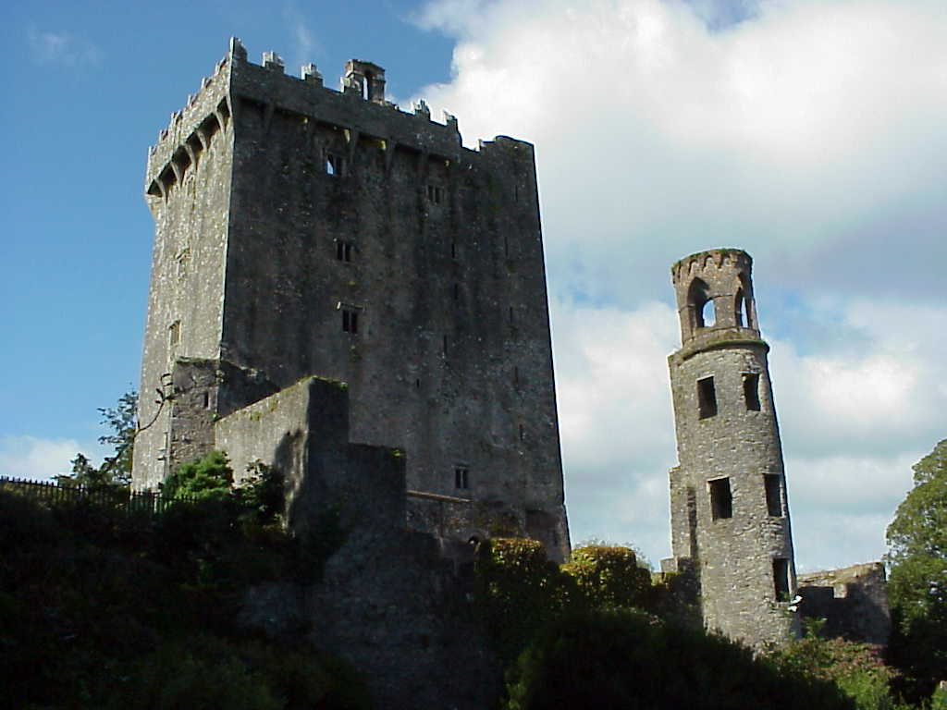
Over to the Blarney township and Mum brought some more gifts in the Blarney woolen mills shop. We saw so many Trafalgar tours buses, but not Gran and Grandad’s, but it brought several performances by Riley’s impression of Gran saying “Orrrr there’s my grandchildren” just the way Gran would do it! He’s a crack up!!
Back on the road, and down to the historic seaside town of Kinsale, then a further 15kms down to the “Old Head of Kinsale”. I particularly wanted to see this place, as it was 8 miles off the coast in 1915 that the Lusitania, my favorite ship, was torpedoed with the loss of 1198 lives, only 200 less than the Titanic.
The Lusitania, and her sister Mauretania, where both built in 1907 as the first ever steam turbine ocean liners. One of my heroes, Charlie Parsons, managed to convince the builders to install his new steam turbine machinery as the propulsion for the ship. The builders were weary, but during the trials of these great ships, the engines performed far greater things than anyone ever imagined, and the Mauretania went on to hold the “blue riband” for the next 35 years! OK, enough ship history, we went back to Kinsale for the night, with some great Atlantic Salmon for dinner washed down with a pint of Guinness at the local pub!

Saturday 16th September
Kinsale Ireland
Weather: Cool rainy start clearing to warm afternoon sunny breaks.
Quote of the day: “Is it too early in the day to be drinking whisky… Nah!”
It was the worst night sleep ever! I thought I had died and was cast among the cutting room floor scraps from “The Commitments” movie. It was only yesterday Anita was commenting on the difference between the English and the Irish, and drew the conclusion the Irish were more jovial, happy and relaxed; well that certainly proved to be true. Our B&B comprised of a small cottage, in a street only wide enough for 1 car, and as we were sleeping on the first floor over looking the street, had a good view of all that happened below. Well, when the pubs down the street closed for the night, all the young people of the town, walked up our street, (up until 2.30am) singing such well known renditions as “My way”, “Green grass of home”, and “one of those Elvis songs”. Its probably the same things that has happened in that street on Friday nights for the past 400 years, although I don’t think Elvis and Tom Jones have been around quite that long; Frank Sinatra, I’m not so sure! It amazed me people of that age know such songs!
By some miracle, we managed to get on the road early, and headed back towards Cork, to Midleton, the home of the “Jameson’s Irish whisky” heritage centre. Since we arrived so early, I had to ask “Is it too early in the day to be drinking whisky?…. Nah!” We had a tour of the old distillery, which was powered by a huge water wheel, and when the water was short they used this cool old beam steam engine! After the tour, the traditional tasting, with me drinking Anita’s share too then back on the road to Cashel, to see the castle on the rock-o-Cashel. Once we got there, Anita was the only one keen enough to get out of the car and have a look. The rest of us said, “It’s just another castle, we’ll wait in the car!” It really was impressive though, stuck up on the rock overlooking the whole town. Anit just had a quick look and we were back on the road to Kilkenny.
Kilkenny is where one of my mates from the steam club in Geelong comes from, and knowing what a dag he is, we had to go and see where he came from. It should also be a closer destination for us to make the quick dash back to Dublin for the airport by 4pm tomorrow.
The hotel was very expensive, but seeing it was our last night, had an indoor swimming pool, plus a kids club to entertain the rug rats, we in! A quick swim before dinner was good since all we had done was sit in the car for 2 weeks, so to get some good exercise and work up a thirst was a good move. We dropped the kids off, I headed to the bar for my first beer, (choosing the Kilkenny cream which I tried once at the Irish pub near our house at home) Anita jumped in the shower, then met me for dinner. We took the opportunity of the peace and quiet to go for a quick drive around the town, which was very interesting, then checked our email on the computer in the bar area of the hotel. Time for bed!

Sunday 17th September
Kilkenny to Dublin, and back to London
Weather: cloudy with drizzly rain.
With the rain outside, a 12 o’clock check out, and a swimming pool handy, we had a leisurely start to the day, with a lie in, cooked breakfast followed by a swim. We finally left the hotel after midday and had a quick look around the streets of Kilkenny. It’s an interesting village, with 2 great churches and it’s own castle as well.
We finally got on the road towards Dublin, stopping at a restored corn mill built in 1840 on the way. Onwards and just outside Dublin, at Naas we stopped for a bite to eat, even though it was around 2.30pm. Lunch was pies and sausage rolls from the local ‘Spar’ supermarket which prepared us for the traffic of Dublin.
A good run on the motorway into Dublin, was followed by a slow journey around the M50 towards the airport. We couldn’t find the Hertz rent a car place, and needing petrol, we stopped at “Dan Dooley” car rentals for fuel. After filling up, I asked the big fat attendant sitting behind the desk for directions to the Hertz depot.
“Down there and round to the left…” I looked down the road and couldn’t see any turn off. A building down the road had a big sign on the top so I again asked, “What past the building there?” he answered very non chalantly “Yeah…”
So off we went armed with our highly accurate directions, down the road, with no left turn in sight anywhere, until finally we turned into a housing estate which turned out to be miles from where we should be! I bet he turned to his mate after we left and said “So I told them down to the left… ha ha ha!” We eventually found the depot, which is where the fun began with our bags. We had to leave most of our bags in storage at the hotel, and with all the goodies we brought, including the antique sign from Killarney we were suffering major disorganisation! Our Ghana-goer bag had split at the seams and the zipper had ‘chucked it in’ and to top it all off, we had to walk to the airport check in which was a few minutes down the road with bags that were impossible to lift, let alone carry! Luckily we found an abandoned airport trolley loaded it up and off we went.
Embarrassingly, we checked in our bags, borrowing sticky tape from the check in girl who then proceeded to tell us we had been down graded to cabin class due to a ticket stuff up. Anita had to go down stairs and sort it out. She managed to get 2 of us into business class, and the other 2 where moved up when 2 seats became vacant at the start of the flight. While sitting there in business class, I asked for a scotch and coke, so the flight attendant gave me this 10 year old single malt whisky; far too good to poison with coke! As I read the label, I realised it was one of the distilleries we had visited on our UK tour 10 years ago, and as it was 10 year old scotch, I had a funny feeling. I saw this actual dram being distilled, and now back in the country 10 years later, I was drinking it! Amazing, don’t you think???
Gatwick airport, and I finally convinced Anita we should struggle with our heavy bags onto the train, rather than pay for a taxi just yet. So after 45 minutes on the train, which would have cost L100 in a taxi, we arrived at the station, then L7.00 taxi fair to the hotel, arriving at 9.30pm and off to bed.

Monday 18th September
Back in London
Weather: drizzly rain.
Anita was paranoid about getting the washing done, and when she found a ‘coin in the slot’ laundromat she shot off like a Bondi tram with the washing bags. The kids and I stayed around the room, and lit up the donkey steam engine Mitch got for his birthday. He enjoyed seeing it run for the first time. I spent the rest of the time catching up on downloading some photos, and labeling them, and fixing up this journal.
We headed out late in the morning, stopping at the concierge to book a ticket for the London Eye tomorrow. We then headed over to the tube station, jumping out at Monument station, as Mitch was keen to find “Pudding Lane” where the great fire of London started, having learned all about it at school. Leaving the station, and the rain already falling lightly, we found the monument, which was actually built by Sir Christopher Wren to remember the great fire. Pudding Lane on the other hand had nothing much to see, which disappointed Mitch.
We then headed over towards the Tower of London, and with the rain still falling, we were beginning to feel a bit wet. Mitch also wanted to see the tower bridge, and as it was indoors, was a good place to shelter for only L18 a family. So in we went, through the exhibitions on the building of the bridge, and the politics against it; all very interesting. We then went downstairs to see the steam machinery used to lift the bridge open to allow shipping through.
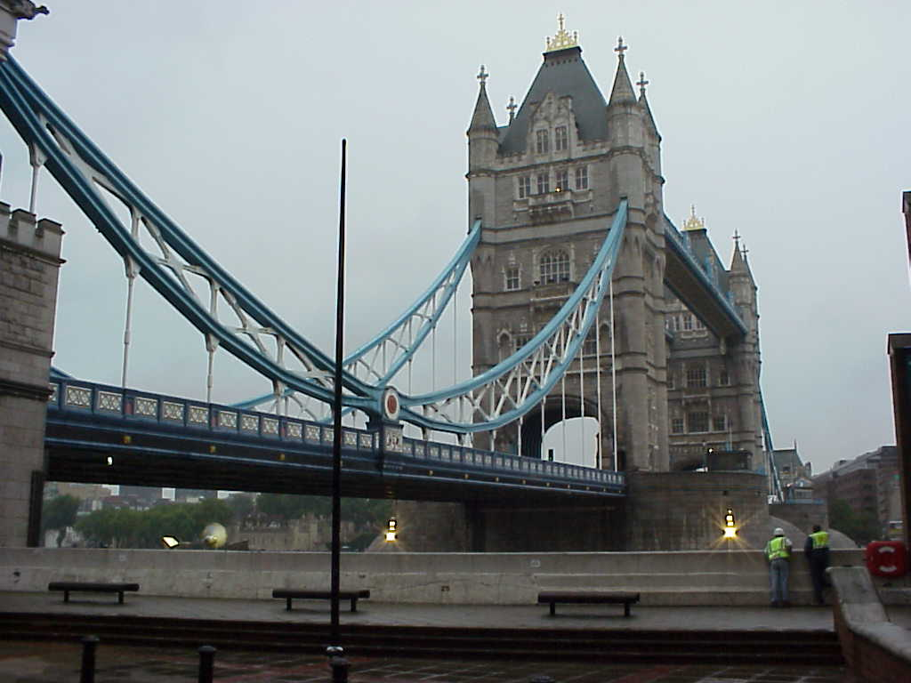
Back out again into the rain, which was still falling. We had a bite to eat at a trendy sandwich shop, only because Riley was desperately hungry and there wasn’t anything else handy. So I ate the most expensive sandwich ever, which was also the best sandwich ever! We all had a sandwich except Riley who had some fruit salad, a coffee each for Anita and I, fruit juice for Mitch and Riley, and 4 packets of crisps to finish off, all for a mere L18. (About $45 Australian, but we try not to think of that!)
At 3.30pm, wet, and sick of the rain, the boys and I decided to abandon the rest of the day and return to the hotel, while Anita went shopping. So the boys and I went back fired up the steam engine again, had a hot shower and watched some tele.

Tuesday 19th September
London
Weather: drizzly rain.
Continuing to explore the city, we got the courtesy bus to the centre, and while looking for a post office to so Anita could post her Mum a birthday present from London, we found a courtyard area surrounded by offices which had a large amount of activity. Upon closer investigation, we found “The Guinness Ice Bar”, which was a bar set up, made completely from ice with a gorgeous brunette pouring the beers. The bar was ice, the lady behind the bar was ice, the wall behind was made from stacks of large blocks of ice, even the billiard table was ice! They were setting it up for a TV commercial, so there were cameras and people everywhere.
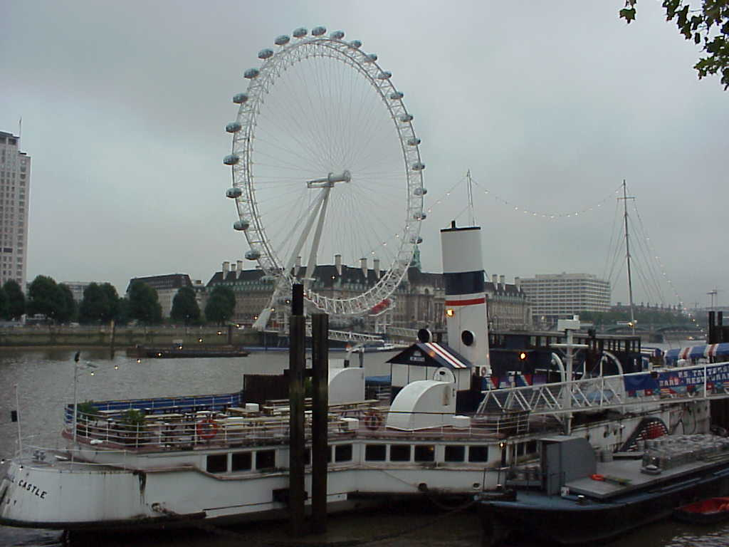
We had tickets booked for the London eye at 12 o’clock, so Anita suggested we head in that direction. The rain was falling, and things were feeling a bit cold and miserable, but we were still determined not to let it dampen our London experience. From the tube station, we headed over to the eye, and of course, took the longest possible route to get there, we got off at embankment station, which turned out to be on the wrong side of the river, and a bit of a walk to get there. (As usual!) Even though we had pre booked tickets, we still had to cue in the rain for before boarding.
The London Eye was a great feat of engineering, and even the rain couldn’t take away our excitement. The only problem was, the windows were fogged up, and spotted with rain, as well as the view not so good on account of the low cloud. But we enjoyed it anyway.
Coming out, and with the worms biting, I spotted a hot dog stand and knowing how good these were in New York decided it would be good for lunch. I didn’t have to look hard to spot it, as it was surrounded by about 6 other identical hot dog stands, all stainless steel, and on wheels to follow the crowds. I approached the man, with Mitch hot on my heels licking his chops and told him we needed 4 hot dogs. “Do you want mustard and onion?” I then decided to ask him how much? “L2.50” Is that for all 4? “No each…” Well that’s about $7 for what I would pay $2 at the most for in Australia! So we high tailed it out of there and headed for Maccas for our last junk food fix! We managed to feed the whole family for L8 instead of L10 for a snack!!
We then went up onto the bridge to look at Big Ben, but it was still raining, and we were wet, so we hurried over to Westminster Abbey, thinking God would save us from the rain, but he wanted a fiver each to get in, so back to the tube station and on to Piccadilly Circus for more shopping!
We walked up Regent street, and found an optometrist to fix Mitchell’s glasses. A black Englishman at the counter, firstly wanted to make a big song and dance about fixing our glasses because we hadn’t bought them there. I got cross with him, and said if they can’t repair glasses we would take our money elsewhere. He went and spoke to the boss who came and replaced the broken nose pad without any fuss, then refused to take any money for his trouble. So I left with my tail between my legs.
We then went back to Hamley’s the biggest toy shop in London, where we had afternoon tea, a look at the toys, and pulled a few tricks for Christmas.
Walking back down Regent street in the rain, Mitch had to stop at the Singapore Airlines office and do some more research for his airline “Star Cruiser”. He left there with a timetable book, and some new ideas on how to beat there standards.
Back to the hotel for a hot shower, dry clothes, then down the road to the Brittania Hotel for tea. We had been there 3 weeks before, and although expensive, not as bad as the restaurant at the hotel. We put the kids to bed, then stressed out over packing up bags ready for a 6am start tomorrow. We have a car organised to take us to the airport at 7am.

Wednesday 20th September
London to Lagos.
Weather: drizzly rain.
Quote of the day: “That’s the trouble with this damn country, everything’s broken!”
Well leaving London, we had the worst driver in the World. He was a Bangladeshi reject that kept calling himself a Briton, who couldn’t drive a greasy stick up a dogs bum! He seemed to have a mild case of epilepsy in the right foot, and so was on and off the accelerator to the point where Riley was chundering all the way to Gatwick airport. Once we arrived and checked in, we had time to kick back in the business class lounge, enjoying a free breakfast compliments of British Airways, before heading back downstairs with the poor people. I found the duty free electronics store, and forked out a fortune on a new game boy for Riley, who had lost his somewhere in London, and had missed it terribly ever since. Back to the lounge and the first scotch of the day, then collected the family and headed for the boarding lounge. On the way, we passed one of the travelators which was stopped so we had to walk around it. At the end, the motor hatch was open and 2 men where hard at work correcting what ever problem there was. I heard one elderly American man grizzling to himself as he walked around, “It’s broken… that’s the trouble with this damn country, everything’s broken!” Boy, I thought to myself, he must have lived a sheltered life!
The flight to Lagos went without a hitch, sitting back in the lap of luxury sipping single malt scotch whisky while watching Clint Eastwood in “Unforgiven”. I’m not really a fan of Western movies, but this one is an oldy but a goody.
Arriving in Lagos, I was surprised to see the AC (air conditioning) was working in the arrival hall as we stepped off the plane. What a surprise! Since coming to Lagos the first time, things were really bad but have been getting progressively better each time we arrive, so this time things should be almost to European standards…. perhaps.
The AC was short lived, and had disappeared by the time we had moved away from the arrivals hall. The travelators too where not working, but instead of like Gatwick, where only one was “broken” and at least they where working on it, here they were all broken, and nobody working on them! (Where was that American man now?)
The problem next was getting down the stairs to the immigration checks, and the escillator wasn’t working either, and with 100’s of people moving down, with a baby stroller half collapsed on the single file stairs blocking the traffic flow while poor Mum and Dad tried to get it back up, with baby still inside, all while the temperature was rising to an uncomfortable level with ever step we descended.
Next comes immigration. We have to wait in a huge cue, which is a bit disorganised, because nobody is quite sure which line to go in, then everyone re-arranges themselves into the correct order. After not waiting too long, our passports are checked by a lady who is stationed a few metres back in the cue from the main desk. I guess she is there in busy times to help complete the “office use only” part of the arrival card, which concerns all the details of the residents permit and visa from your passport. Then its back in the cue to the next station, which comprises of the 3 wise men all sitting in a row like judges in the high court. Eventually you make it to them and they take your passport, passing it one to the next while the man on the end calls out names of people in the cue in random order, adding to the confusion. He called out the name “Oh yee” then looked around and called again, and again… “Could that be Dye” I asked? He looked again, and gave us our passports, and we were at last in Nigeria!
Now the fun really starts. Imagine the baggage collection belt half the size of any other airport, add to that 2 planes arriving at the same time, then put some refurbishment of the adjacent baggage belt with barriers limiting the surrounding room to about 2 – 3 metres, then push all the people in with trolleys, one isle blocked by a lady in a wheel chair, the other with a baby stroller (yes, the one that collapsed on the stairs still with the baby inside) and you have the mayhem of baggage collection at Mutala Muhammad airport! This is the scene that greeted us when leaving the immigration desk. There were so many people trying to get in with there trolleys, that the lucky people who had collected their luggage couldn’t get out! I had seen our bags pass twice already, but there was no way to get near the belt, which was now full because nobody was able to remove any bags!
At one point, a heavy steel sign telling people it was it was not permitted to cross the baggage belt, which was tied to another sign at the opposite end with red/white barrier tape, caught on the bags overflowing from the belt, sending the sign crashing down almost injuring the man standing in the middle obviously there to enforce the signs orders, then the other sign too was pulled down by the barrier tape from the sign now attempting to go around with the baggage resulting in a terrible crash.
Anita was taking it hard, and was getting a little upset, so I took her and the boys over to a quiet corner, well away from the mayhem. Her and Riley both were red in the face and perspiring, Mitch and I seem to cope better, but it was rather hot in there. While Anita was waiting, all these expat men kept coming to her asking if she could watch over their bags while they went in search of there next one.
I too felt like a mother bird stealing a morsel of food and bringing it back to the sanctuary of our nest. I would stand with the rest of the crowd, and as one of our bags came into view, I swooped in pushing and shoving, then a quick snatch and back out through the madding crowd back to our sanctuary. Anita now had a large collection under her care. Finally I managed to snare our last bag, then it was off to find a trolley, if that was possible, as many people who had given up trying to get there bags sat back, but they all had empty trolleys, realising what a valuable commodity they can be! A porter was brining more trolleys in through the door on the opposite side of the crowd still gathered around the baggage belt so after yet another pushing and shoving match, I got my trolley back to our sanctuary, loaded up and time to get out. Over to the “nothing to declare” area, and the uninterested customs man asked the usual “what is in these bags?” to which I answered the usual ‘clothes’. He gave the top bag a prod, and told us to go. I thanked him in Yoruba (the local language) and stepped through the doors, then out to the front of the airport. We faced the sea of 10,000 faces that congregate outside the airport, all looking at us, until we finally found Godson our guide, who ushered us towards the carpark, past many people who offer to help carry our bags, or the lazy ones who just plain ask for money till we finally get to the car. From our arrival at 5.45, the whole escape exercise had taken us until 7pm. Thinking back to the American man at Gatwick, I wondered what he would think about that, even to the point that the car park was mostly in darkness because the majority of street lights did not work.
Godson works for “Five star Travel” who do our airport meet and greets, but looks after many clients and with the airport so busy, partly because our plant is having the official opening tomorrow, and there are many delegates flying in from all over the world to take part in the celebration. So Godson asks us to be patient while he finds his next meet. So we wait in the car for nearly 1 hour, in the dark carpark getting with the driver outside praying to Alah, and our armed policeman sitting nearby with his AK-47 ready to shoot any malaria ridden mosquito who dared to actually bite us. Eventually with the next flight also delayed, Godson gives up waiting and sends us with our driver off on the short drive to the hotel only a few kilometres away.
The traffic is horrendous! Getting out of the car park is bad enough, but then we get onto the free moving road out of the airport at last. This of course is short lived as we hit the traffic of Lagos, and things go down to a crawl and eventually stop all together. The major road leading to the airport was closed from 4 lanes down to 2 when I left 4 weeks ago, while one side of the road had been dug up and rebuilt read for final sealing. The trouble is, that the traffic is so bad, that people get sick of waiting and so break through the barriers closing off the freshly prepared road, driving on it which means it has to be re done before sealing. And so 4 weeks later, it is still not finally sealed and people are still short cutting over the new section. There is also supposed to be 2 lanes, but with people trying to jump the cue, it ends up in 5 lanes, which then has to squeeze back to 2 at the bottle neck. We were getting nowhere, and the boys who were now tired where getting restless, noisy and out of control. When the whole situation seemed hopeless, the driver surprised us by doing a ‘U’ turn and heading back towards the airport, then onto a back road for the long way around, but at least we were getting somewhere.
We arrived at the hotel around 8.30pm to find there was no room ready for us. The Sheraton Hotel is very popular because its close to the airport, so there is always people coming and going, but with the extra people coming for the plant opening, things were really out of control. They did have one room for us, but it wasn’t made up, and as a family we should get 2 rooms. Anita jumped up and down, and demanded action, which made the desk clerk check the computer again, saying “Oh, Anita Dye, yes we have 2 rooms booked for her, but Mark Dye has only one room”. Great! Now we have 3 rooms! But they still aren’t ready, but a little pressure using the cranky kids as a lever, we got our rooms opposite each other, instead of adjoining, on the 3rd floor by 9pm, more than 3 hours after arrival in Nigeria.
The next surprise, was that because so many delegates are traveling to Bonny Island tomorrow, there is no transport available for us. So we are stuck in the hotel for an extra night, with 2 other boys from my shift also returning back from leave, so my shift will have 3 people missing for the first dayshift on Friday. But what can I do, but kick back on the company account, drink some more beer by the pool and enjoy our extended holiday in Lagos.


